Nuts phenological development and true bugs feeding activity as factors in the occurrence of main damages in two European hazelnut districts

Stefano Speranza^{1,4}, Mario Contarini¹, Luca Rossini^{1,3}, Carlo De Spirito¹, Agusti Romero², Andrea Pezzolla¹, Mercè Rovira²

1 Dipartimento di Scienza Agrarie e Forestali (DAFNE), Università degli Studi della Tuscia, Viterbo, Italy
2 Institut de Recerca i Tecnologia Agroalimentàries (IRTA), Mas Bové, Constantí, Spain
3 Service d’Automatique et d’Analyse des Systèmes, Université Libre de Bruxelles, Brussels, Belgium
4 National Biodiversity Future Center (NBFC), Palermo, Italy

Abstract
Hazelnut cultivation is continuously exposed to biotic adversities, typically insect pests causing considerable production losses. Most of the damage is the result of feeding activity of ‘true bug’ species (Hemiptera: Heteroptera), affecting both the quality and quantity of production. True bugs can cause the traumatic abortion of cotyledon tissues or an alteration of the nut. The latter consists in the necrosis of the kernel with the appearance of black or white spots and shrivelling. This damage relates to the timing of the feeding activity and on the nuts’ phenological stage. This study aims to evaluate the relationship between the nut phenological stages and some of the most important true bug species in two different European hazelnut districts. To pursue this aim, an experiment was conducted in the Tarragona hazelnut district (Spain) and in the Viterbo hazelnut district (Italy). Hazelnut plants were selected, and some branches were wrapped with net sleeves. In each net sleeve, Palomena prasina, Gonocerus acuteangulatus, and Nezara viridula specimens were inserted when the nuts reached different stages of phenological development. As a result, two developmental stages of the nut’s kernel were identified during which the feeding activity of the true bugs cause traumatic abortion and ‘cimiciato’, respectively. According to the phenological scale developed by IRTA, these two stages are g2/G1 and G4/G5. These results are of great importance in the development of control strategies and the information provided will be helpful in reducing the amount of treatment required to control true bugs.

Keywords: Corylus avellana, early nut drop, kernel damage, Palomena prasina, Gonocerus acuteangulatus, Nezara viridula

INTRODUCTION
In recent years, hazelnut (Corylus avellana L.) cultivation and consumption has been increasing worldwide, fuelled by the high nutritional values of its fruits and their wide use in bakery products, as well as in chocolate manufacture (Bozoglu et al., 2019; Köksal et al., 2006).
C. avellana is naturally present in the Mediterranean basin. It is widely cultivated in Turkey and Italy (the largest producers worldwide) as well as Spain. Despite its known resilience to adversities, hazelnut plants are currently exposed to several insect and mite pest species affecting both the quality and the quantity of production (Aliniazee 1998; Contarini et al., 2022; Drais et al. 2022).
Among insect pests, true bug species (Hemiptera: Heteroptera) deserve particular attention. In the Mediterranean basin, the most common and destructive true bug species are Gonocerus acuteangulatus (Goeze) (Hemiptera: Coreidae), Palomena prasina (L.), and Nezara viridula L. (Hemiptera: Pentatomidae) (Moraglio et al. 2009; Tuncer et al. 2005; Çerçi and Koçak 2017). In several countries the situation is being further complicated by the recent introduction of the highly polyphagous brown marmorated stink bug Halyomorpha halys Stal, native to East Asia (Wermelinger et al., 2008; Bosco et al., 2018).
Adults and nymphs of true bug species, through their piercing-sucking mouthparts, can cause different kinds of damage to kernels but the extent of damage strongly depends on timing of the feeding activity. If the bugs feed on developing nuts, the consequence is a seed abortion, usually followed by a premature drop. Otherwise, late feeding activity on nuts results in alteration of the kernel shape: typical effects are shrivelled kernels showing black or white spots and spongy tissue (Tavella et al., 2001; Tuncer et al., 2005; Romero et al., 2009). Besides kernel malformation, an alteration of the organoleptic characteristics and a bad taste is associated with infested nuts. Not all these expressions of feeding activity are unequivocally identified in each of the different hazelnut-producing countries, thus the Italian term “cimiciato” summarizes all the above-mentioned defects.
Although G. acuteangulatus, P. prasina, N. viridula and H. halys cause the same damage within hazelnut plantations, their presence and activity are different in Mediterranean areas. P. prasina, for instance, is particularly common and active in the Black Sea hazelnut district (Turkey) (Tuncer et al., 2005; Saruhan and Tuncer, 2009), Tarragona (Spain) (Romero et al., 2009; Rovira et al., 2021), and in some regions of Italy such as Piemonte and Campania (Tavella et al., 1997 and 2001; Moraglio et al., 2018). Conversely, G. acuteangulatus has a more localised distribution and is only occasionally highly damaging, typically in the Italian regions of Lazio and Sicily (Tavella et al., 2001). N. viridula activity is reported in several hazelnut areas of Italy and Spain where it can exploit a broad range of cultivated and non-cultivated plants including the hazelnut. H. halys has been recently detected in several Mediterranean Countries becoming the key pest in some areas such as Piemonte region (Italy) and Georgia.
Although a number of studies link the activity of true bugs with damage to nuts (Tavella et al., 2001; Tuncer et al., 2005), the identification of the most susceptible phenological stages is still being explored (Hamidi et al., 2022). This study will explore this topic, focusing on the damaging activity of three of the most destructive true bugs in two experimental fields located in Italy and Spain: G. acuteangulatus and N. viridula in an experimental field located in Viterbo (Italy), and P. prasina, in an experimental field located in Tarragona (Spain). H. halys was not included in this study because its presence and effect in both areas was negligible at the time of the survey. For the purposes of this research, it was assumed that the predominant true bug species in a given area was responsible for traumatic abortion and ‘cimiciato’. As well as an in-depth study regarding the timing of the true bug infestation, this research also compared two scenarios characterised by different species.
The study was divided into two steps: i) an analysis of the relationship between the hazelnuts phenological stage and P. prasina activity on the Spanish experimental field, and ii) a repetition of the same experiment in the Italian field, focusing on G. acuteangulatus and a deeper exploration of knowledge related to the occurrence of ‘cimiciato’, using N. viridula specimens.

MATERIALS AND METHODS

Study site

Spain
The experiment was conducted on a hazelnut plantation located in the Tarragona (Catalonia, Spain) district (41°11’15.72’’ N - 1°9’23.76’’ E). The orchard was established in 2000 with plants belonging to ‘Tonda di Giffoni’ cultivar. Hazelnuts were planted with a spacing of 6 x 3.5 m and provided with a drip irrigation system. In this orchard, 12 plants were randomly selected to be included in this study.

Italy
The experiment was conducted in the Viterbo hazelnut district (Latium, Italy) on the ‘Vignola’ farm (42°17’23.86’’ N - 12°17’00.51’’ E), where hazelnut cultivation spans several tens of hectares. The orchard is flat and irrigated, and consists of thirty-year old hazelnut plants grown as multi-stemmed bushes. The predominant cultivar is the ‘Tonda Gentile Romana’ with a few representatives from the ‘Nocchione’ to ensure pollination. The experiment concentrated on a 3000 square-metre sub-plantation, where the relationship between the kernel phenological stage and true bug activity was examined. In this sub-plantation no control actions against insect pests were carried out during the season, to avoid interference with experimental activity. Eighteen plants were randomly selected and divided into three groups: T1 and T2, where further trials were conducted at different moments during the season, and C the unbiased control.

Assessment of nuts phenological development
In 2018 a nut development-stage scale was created that relies on the morphological growth of the kernel. This scale has been adapted by Institut de Recerca i Tecnologia Agroalimentàries (IRTA). From late May to late July, 100 nuts were picked at random weekly, directly from the plants and brought to the laboratory. Nuts were subsequently opened in half to measure the kernel diameter. Each collected nut was placed in a category (from g to G5) according to the stage of development reached by the kernel. The phenological development of kernels is represented in Table 1 and Fig. 1.
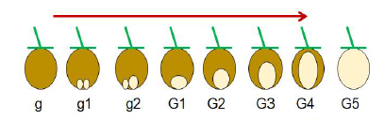
Figure 1. Graphical representation of the scale developed by IRTA, showing the kernel growth divided into stages of development, each of which has been denoted by an alphanumeric code.

Table 1. Nut phenological stages with the associated description of kernel development
Kernel phenological stage | Description of kernel development
g | No ovule in the medullary tissue of the ovary is observed
g1 | Two ovules of the same size are observed
g2 | One ovule more developed than the other is observed
G1 | The kernel occupies more than ¼ of the nut
G2 | The kernel occupies between ¼ and ½ of the nut
G3 | The kernel occupies between ½ and ¾ of the nut
G4 | The kernel occupies more than ¾ of the nut
G5 | The kernel occupies the entire nut

Nuts phenological development and true bug feeding activity relationships

Spain
On each of the 12 hazelnut plants considered in the orchard, three one-metre-long branches were selected. To protect the nuts from the true bug activity, the selected branches were wrapped with handmade sleeves composed of a nylon net bag that enclosed the apical part of the branch. A total of 36 sleeves were deployed in the field in the first days of May 2018, before the arrival of true bugs into the orchard. Three treatments, hereafter denoted by T1, T4, and C, were compared to identify the phenological stage of the kernel at the onset of traumatic abortion, and corked and shrivelled nuts, i.e., ‘cimiciato’, occurs after the bugs’ feeding activity. For each treatment, 12 sleeves were considered: one sleeve per identified plant, that is, each plant is a block of the experimental scheme.
To assess the traumatic abortion, four adult P. prasina were introduced on May 17th into the T1 sleeves, when kernels reached the phenological stage g1. True bugs were then removed after 7 days.
To assess the onset of ‘cimiciato’, four adult P. prasina were inserted into T4 sleeves on July 19th, when the kernels reached the G4-G5 phenological stage. True bugs were removed after 7 days.
In the control sleeves, (C), no true bugs were inserted. For both experiments P. prasina specimens were used because this was the most recurring species in the orchard, and the one responsible for majority of the nuts’ damage (Romero et al., 2009; Rovira et al., 2021).
Each week, the sleeves were visually monitored. The dropped nuts were removed, counted, and examined separately for each sleeve. Any nuts that dropped after August 13th were not immediately opened but classified as ‘fallen at the end of the physiological maturation process’. On August 27th, all the sleeves were removed, and the nuts contained were brought to the laboratory where they were opened to assess the health status.

Italy
This stage of the experiment was conducted on the ‘Vignola” farm by randomly selecting 18 plants, subsequently divided in the three groups T1, T2, and C. From each of these plants, at the end of May 2019, five one-metre-long branches were selected, and the developing nuts were counted. The branches were subsequently wrapped with handmade nylon net bags to prevent nuts from the feeding activity of true bugs. As already described for the Spanish experimentation, each plant provided for a T1, T2, and C sleeve was considered as a block of the experimental scheme.
G. acuteangulatus specimens collected from the same farm were inserted into the sleeves at different times during the season, based on the development of the nuts. One bug for every five nuts contained in each sleeve was inserted into the T1 sleeves on June 27th, when nuts reached the phenological stage g2/G1, and into the T2 sleeves on July 18th, when nuts reached the stages G4/G5. True bugs were kept in the sleeves for seven days and subsequently removed. No true bugs were inserted into the C sleeves. On September 5th, all the wrapped branches were cut, the nuts were collected and brought to the laboratory where they were opened to assess the health status.

Assessment of the timing and occurrence of corked and shrivelled nuts
A second experiment was carried out in 2022 on 18 plants from the Vignola farm, in the Viterbo hazelnut district, divided evenly into T1, T2, and C groups. At the end of May, three branches per plant were randomly selected and the developing nuts counted. The branches were subsequently wrapped with net sleeves, as already described for the 2019 experimentation. The phenological development of the nuts was assessed weekly from May to July. N. viridula specimens were introduced into each sleeve according to the nut's development. One N. viridula specimen per five nuts was introduced into the T1 sleeves on June 22nd, when nuts reached the average developmental stage of G2/G3. True bugs were kept in the sleeves for 7 days, and then manually removed. The same procedure was carried out in the T2 sleeves: N. viridula specimens were introduced on July 7th, when nuts reached the average developmental stage of G4/G5. No true bugs were introduced into the sleeves of the C group. On August 18th, all the wrapped branches were cut, the nuts were collected and brought to the laboratory where they were opened to assess the health status.
Data analysis
Differences between the hazelnut groups were assessed through a one-factor Generalized Linear Model (GLM) with a binomial distribution and the Bonferroni post hoc test ($α$=0.05). Each hazelnut group was considered an independent variable while, depending on the case, aborted hazelnut or hazelnut with ‘cimiciato’ were considered dependent variables. Calculations were carried out with R software, using the functions glm.nb() in the lme4 package, cld() in the multcomp package, and emmeans() and pairs() in the multcompView and emmeans packages respectively.
RESULTS AND DISCUSSION
The Spanish experiment conducted in May 2018 highlighted no statistical differences between the number of nuts that aborted and fell across the three treatments considered (Fig. 2) (GLM, Z=1.085, P=0.8339). Accordingly, the feeding activity of P. prasina specimens on g1 stage nuts did not induce an observable increase in the number of aborted nuts.
On the other hand, the number of nuts with ‘cimiciato’ in the T4 sleeves was significantly higher (Fig. 2) than that observed in the other treatments (GLM, Z=-5.689, P<.0001). This could suggest that once the nuts reach the G4-G5 phenological stage they are susceptible to the insect's feeding activity, resulting in the emergence of the ‘cimiciato’ damage.
The Italian experiment conducted in 2019 assessed whether G. acuteangulatus induced a significantly higher occurrence of abortion on nuts at g2/G1 stages (T3), in comparison to T2 and C (Fig. 3) (GLM, Z=-4.934, P<.0001). The presence of empty nuts in T2 and C can be explained by the physiological alterations of the plant often induced by climatic conditions between April and July (Silva et al., 1996).
The results of the experiments conducted in Spain and Italy are helpful to identify the phenological stages during which true bug activity induces abortion. Our findings show that the onset of abortion does not occur if true bugs come into contact with nuts when they are still in the g1 stages, but if it happens during the g2/G1 stages it results in fallen nuts or the appearance of empty nuts.

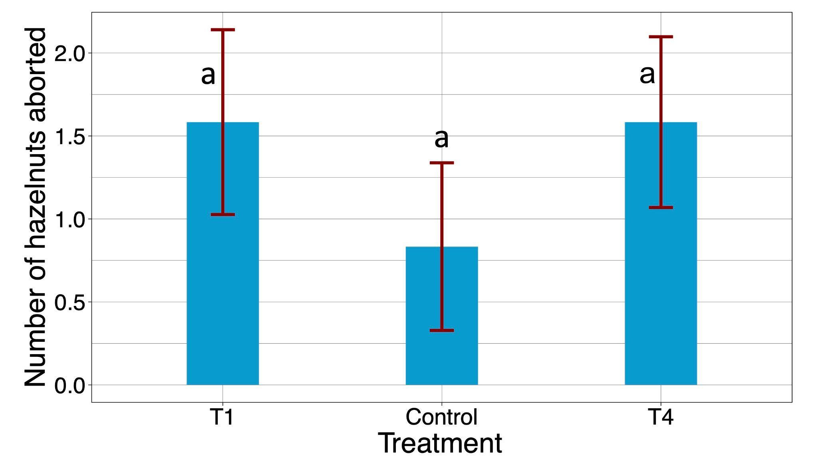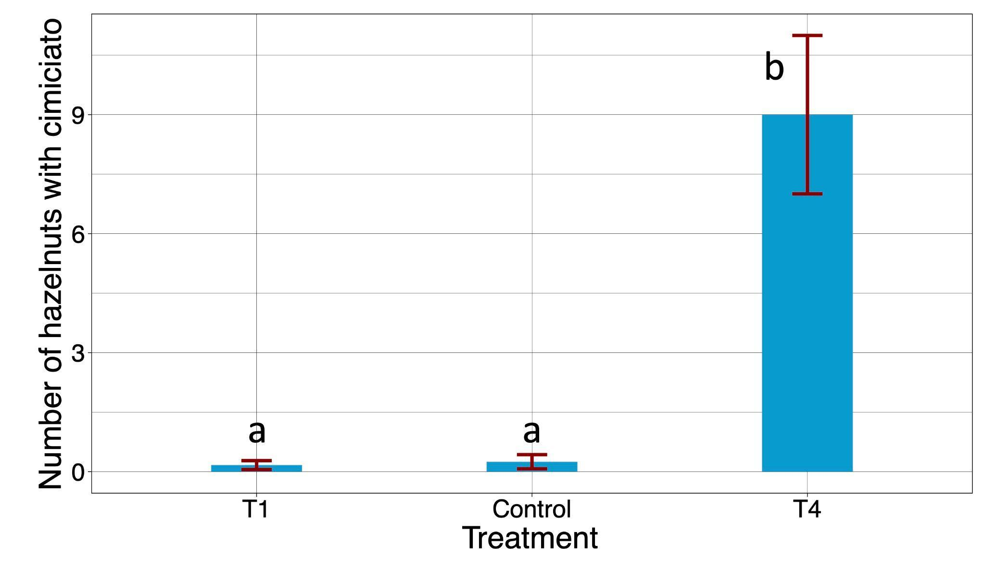
Figure 2. Results of the experiment conducted in the Tarragona hazelnut district (Spain). The left graph reports the number of nuts aborted (mean ± sem), while the plot on the right reports the number of nuts with ‘cimiciato’ (mean ± sem), i.e., corked and/or shrivelled nuts. Different letters indicate significant differences between the treatments T1, T4, and Control (Bonferroni post hoc, $α=0.05$).

The portion of the study conducted in Italy with specimens of G. acuteangulatus placed in contact with G4/G5 stage nuts confirmed findings from the Tarragona site. The occurrence of ‘cimiciato’ was significantly higher in T2 than in the control sleeves (GLM, Z=-4.968, P<.0001), highlighting that the onset of this type of damage is related to the advanced development of kernels.
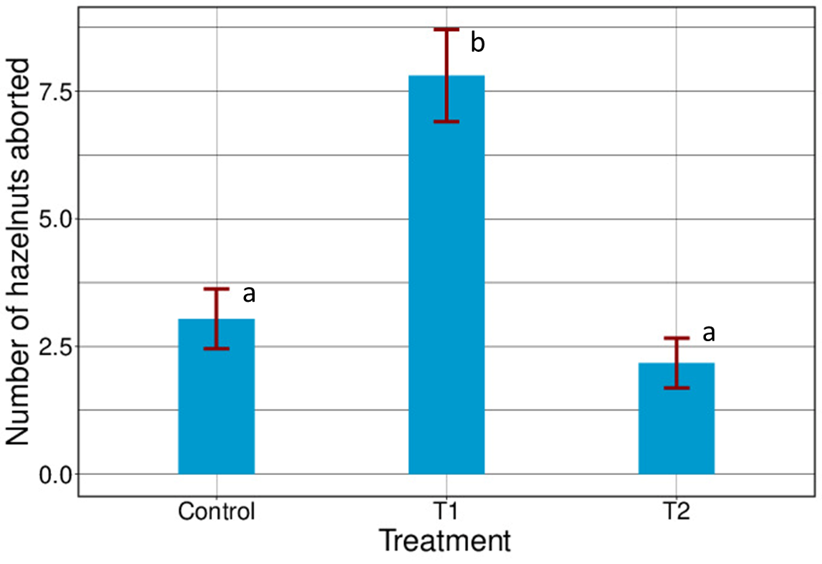
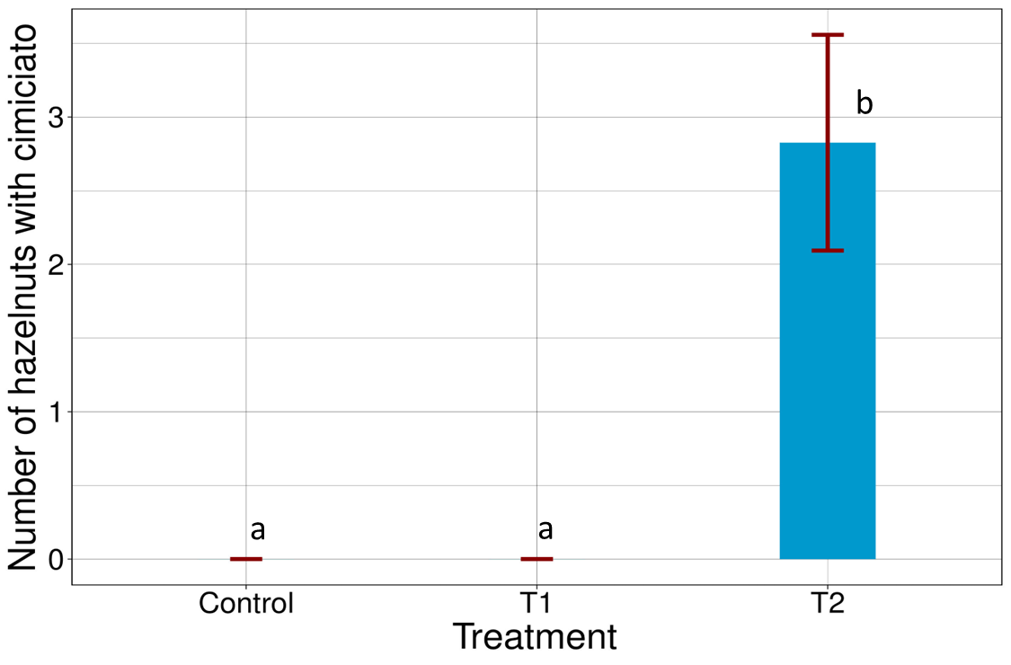

Figure 3. Results of the experiment conducted in the Viterbo hazelnut district (Italy) in the 2019 season. The left plot reports the number of nuts aborted (mean ± sem), while the right plot reports the number of nuts with ‘cimiciato’ (mean ± sem), i.e., corked and/or shrivelled nuts. Different letters indicate significant differences between the treatments T1, T2 and Control (Bonferroni post hoc, $α=0.05$).

The experiment conducted in the Vignola farm in the growing season 2022 targeted an in-depth investigation of the relationship between the onset of ‘cimiciato’ and the phenological development stage of the nuts. This second experiment focused attention on an even more restricted part of true bug feeding activity: Figure 4 shows the occurrence of the damage when nuts were exposed to N. viridula at stages G2/G3, denoted as ‘early’ and G4/G5, denoted as ‘late’. Statistical analysis highlighted that ‘cimiciato’ damage occurs when the nuts reach the G4/G5 development stages, clearly identifying the stage of susceptibility to the feeding activity of the phytophagous. No statistical differences were found between the ‘early’ and the ‘control’ groups (GLM, Z=-0.843, P=1), or between the ‘early’ and ‘late’ groups (GLM, Z=-3.726, P=0.0006). The only difference found was between the ‘late’ and ‘control’ groups (GLM, Z=5.464, P<0.0001), confirming that ‘cimiciato’ occurs once the G4/G5 development stages are reached by the nuts.

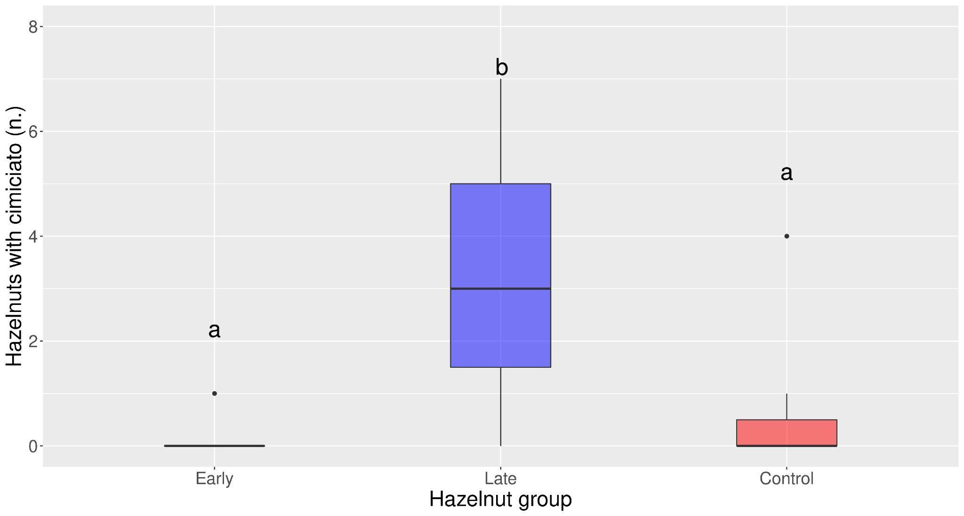
Figure 4. Nuts with ‘cimiciato’, i.e., corked and/or shrivelled nuts, caused by N. viridula specimens put in contact with nuts at G1/G2 phenological stages, denoted as ‘early’, and at G4/G5 phenological stages, denoted as ‘late’. Different letters indicate significant differences between the treatments (Bonferroni post hoc, $α=0.05$).

CONCLUSIONS
P. prasina, G. acuteangulatus, and N. viridula, represent the most damaging insect pests in the areas where the experimentation was conducted, i.e., Tarragona and Viterbo. This study confirms that these true bug species are responsible for traumatic abortion and ‘cimiciato’ exclusively when the nuts reached the phenological stages g2/G1 and G4/G5, respectively.
This finding will be useful for establishing guidelines for the management of these pests in hazelnut orchards. It will enable increased efficacy by supporting the application of control measures not only when the true bugs exceed the damage thresholds, but also when their presence is associated with the most susceptible stages of the nuts revealed by this study.
The BBCH scale was recently introduced for hazelnut (Taghavi et al., 2022); the level of detail of BBCH and IRTA phenological scales may differ in some key phases and so further studies should be addressed even in this direction.

ACKNOWLEDGEMENTS
This work was supported by the European Commission (project PANTHEON - Precision farming of hazelnut orchards) under Grant 774571. L.R. is funded by MUR (Italian Ministry of University and Research) in the framework of the European Social Funding REACT-EU - National Program for the Research and Innovation 2014-2020. The research was carried out in the frame of the MIUR (Ministry for Education, University and Research) initiative ‘Department of Excellence’ (Law 232/2016). The authors are grateful to Romina Caccia, Lorenzo Bracci and Andrea Procaccioli for their assistance and for the field work. The authors are grateful to the CERCA Programme/Generalitat de Catalunya, and ERASMUS Programme.

Literature cited
AliNiazee, M. T. (1998). Ecology and management of hazelnut pests. Annual Review of Entomology, 43, 395.
Bosco, L., Moraglio, S. T., Tavella, L. (2018). Halyomorpha halys, a serious threat for hazelnut in newly invaded areas. Journal of Pest Science, 91(2), 661-670.
Bozoglu, M., Baser, M., Kilic Topuz, B., Alhas Eroglu, N. (2019). An overview of hazelnut markets and policy in Turkey. Journal of Agriculture and Nature, 22 (5), 733-743.
Çerçi, B., Koçak, Ö. (2017). Further contribution to the Heteroptera (Hemiptera) fauna of Turkey with a new synonymy. Acta Biologica Turcica, 30(4), 121-127.
Contarini, M., Rossini, L., Di Sora, N., de Lillo, E., Speranza, S. (2022). Monitoring the bud mite pest in a hazelnut orchard of central Italy: do plant height and irrigation influence the infestation level? Agronomy, 12, 1982. https://doi.org/10.3390/agronomy12081982
Drais, M. I., Rossini, L., Turco, S., Faluschi, A., Mazzaglia, A. (2023). Modelling germination and mycelium growth rates of Monosctichella coryli under constant temperature conditions. Fungal Ecology, 61, 101201. https://doi.org/10.1016/j.funeco.2022.101201
Hamidi, R., Calvy, M., Valentie, E., Driss, L., Guignet, J., Thomas, M., Tavella, L. (2022). Symptoms resulting from the feeding of true bugs on growing hazelnuts. Entomologia Experimentalis et Applicata, 170, 477 - 487
Köksal, A. İ., Artik, N., Şimşek, A., Güneş, N. (2006). Nutrient composition of hazelnut (Corylus avellana L.) varieties cultivated in Turkey. Food Chemistry, 99(3), 509-515.
Moraglio, S.T., Boso, L., Tavella. L. (2018). Halyomorpha halys invasion: a new issue for hazelnut crop in northwestern Italy and western Georgia? Acta Horticulturae 1226, 379-384.
Moraglio, S., Guidone, L., Tavella, L., Valentini, N., Me, G. (2009). Susceptibility of hazelnut to the attacks of the nut weevil and other pests. Acta Horticulturae, (845), 445-450.
Romero, A., Tous, J., Martí, E. (2009). White Spots in Hazelnut Kernel: Symptoms, causes and Quality Loss. Acta Horticulturae, 845, 607-612.
Rovira, M., Gatell, J.M., Pezzolla, A., Climent, M., Barrios, G., Romero, A. 2021. Efectos provocados por la actividad trófica del chinche Palomena prasina L. en las avellanas: caída prematura y manchas blancas en el grano. Fruticultura, 81,50-63.
Saruhan, I., Tuncer, C. (2009). Population density and fluctuations of the Green Shield Bug (Palomena prasina L. Het.: Pentatomidae) in hazelnut orchards of Turkey. Acta Horticulturae, 845, 549-554. https://doi.org/10.17660/ActaHortic.2009.845.86.
Silva, A. P., Ribeiro, R. M., Santos, A., Rosa, E. (1996). Blank fruits in hazelnut (Corylus avellana L.) cv.‘Butler’: characterization and influence of climate. Journal of Horticultural Science, 71(5), 709-720.
Taghavi, T., Rahemi, A., Suarez, E. (2022). Development of a uniform phenology scale (BBCH) in hazelnuts. Scientia Horticulturae, 296, 110837.
Tavella, L., Arzone, A., Sargiotto, C., Sonnati, C. (1997). Coreidae and Pentatatomidae harmful to hazelnuts in northern Italy (Rhynchota Heteroptera). Acta Horticulturae, 445, 503-509.
Tavella, L., Arzone, A., Miaja, M.L., Sonatti, C. (2001). Influence of bug (Heteroptera Coreidae and Pentatomidae) feeding activity on hazelnut in Northeastern Italy. Acta Horticulturae, 556, 461-467.
Tuncer, C., Sarahun, I., Akça, I. (2005). The insect pest problem affecting hazelnut kernel quality in Turkey. Acta Horticulturae, 686, 367-375.
Wermelinger, B. E. A. T., Wyniger, D., Forster, B. E. A. T. (2008). First records of an invasive bug in Europe: Halyomorpha halys Stal (Heteroptera: Pentatomidae), a new pest on woody ornamentals and fruit trees?. Mitteilungen-Schweizerische Entomologische Gesellschaft, 81(1/2), 1.

