Territorial and Individual Educational Inequality: a Capability Approach Analysis for Italy.

Abstract
This paper aims to investigate territorial and individual inequality in education according to Sen’s Capability Approach that focuses on how public and private resources may be “converted” into educational attainments. We analysed the Italian case by constructing a new longitudinal dataset from 1993 to 2012 using repeated cross-sections of the main social survey by the Italian Statistical Institute. We examined the educational divide between the Centre-North and the South using the Oaxaca-Blinder decomposition and we estimated the Educational Kuznets Curve through a dynamic panel model. According to the results, the Southern educational gap is mainly influenced by the relative ineffectiveness of public expenditure in Southern Italy, where private economic wealth has a stronger educational impact. We verified Kuznets’s hypothesis concerning the inverted U-shaped relationship between educational inequality and attainments. Moreover, individual educational inequality appears to be path dependent, positively linked to economic inequality and negatively influenced by educational public expenditure.

JEL codes: I24, I25, I28, C51

Keywords: Educational Inequality, Educational Kuznets Curve, Capabilities, pseudo-panel, dynamic panel model

1. Introduction
Education is a central factor for social and economic progress and many studies have highlighted various aspects that make education a bridge between economic system and society (Vladimirova and Le Blanc, 2015; Rambla and Langthaler 2016; UNESCO 2017). In theoretical and empirical economic growth literature, education is mainly conceived as human capital (Lucas, 1986) and human skills, i.e. entrepreneurial, managerial and technical skills, (Dosi et al. 1988; Lall, 2001) which, interacting positively with the inputs of production process, drive economic development (Guarini et al., 2006; Guarini, 2009); Jalil and Idress, 2013). In microeconomic literature, two main lines of research have been developed: firstly, a human capital investment function has been studied to capture economic returns (Becker 1964; Mincer 1974; Fuklumura, 2017); secondly, an educational production function has been estimated in order to examine how one’s schooling and socio-economic context influence the qualitative outcome of a student (Hanushek, 1997,2002; Lien, 2006; Laureti et al, 2014). From a political point of view, education assumes a central role. European Union policies focused on education as being an instrument of social inclusion as well as an engine of economic competitiveness. The previous Lisbon Strategy and the current Europe 2020 Strategy for the 2014-2020 period show the efforts the European Union has made to promote educational development, relaunch economy and accelerate the process of “smart”, “sustainable” and “inclusive” growth. In order to develop this strategy, the European Union has fixed two specific targets concerning the percentage of early school leavers and of tertiary students in the population. In this direction, we took simultaneously into account these two educational targets by focusing on differences in the number of years of education, which are examined using Amartya Sen’s Capability Approach. More specifically, we investigated inequality in education between Italy's two main geographical areas, and among Italian citizens by using the data obtained from the “Aspect of Daily Life” (ADL) survey, for the first time. This survey has been carried out annually by the Italian Statistical Institute (ISTAT) since 1993. The Italian case is interesting because the social and economic disparity between the Centre-North and disadvantaged South and Islands (henceforth South) implies that Italian regions attain the highest (such as Lombardia) and the lowest positions (such as Calabria) in the European regional rankings of economic and social development. After carrying out a review of the literature concerning educational inequality, we conducted empirical analysis: firstly, we investigated the factors influencing the educational gap at regional level using the Oaxaca-Blinder decomposition; secondly, we estimated a dynamic panel model using the GMM approach in order to identify which variables affect individual educational inequality by estimating the Educational Kuznets Curve model with public and private resource variables. The results show that there is a significant Southern educational gap in terms of years of education. Private economic wealth affects education more in the South than in the Centre-North. As regards the allocation of public resources in education, public investments in Central and Northern Italy appear to be more effective, even if more funds are allocated in Southern Italy. We also found significant evidence of an Educational Kuznets Curve describing an inverted U-shaped relationship between levels of education and educational inequality. Moreover, inequality in private economic wealth strongly influences educational inequality, while public expenditure seems to be a valid instrument for achieving educational equity.
The original use of a longitudinal database and the territorial perspective of the Capability Approach analysis are the main strengths of the paper. Indeed, most of the studies on this topic use cross-sectional data to analyse a phenomenon that is essentially longitudinal, therefore panel or longitudinal survey data are required in order to analyse the relationship between the territorial/individual educational levels and the resources used in education while controlling for individual heterogeneity. In addition, cross-sectional data are not suitable for testing Educational Kuznets Curve (Deininger and Squire, 1998, Meschi and Scervini, 2014). However, due to the high costs and methodological issues that reduce the information obtained from panel samples, this type of statistical data is seldom available. On the other hand, cross-sectional social surveys are widely carried out on a regular basis thus generating a large amount of available independent cross-sectional data. In this paper, we created a unique dataset by combining micro-data for the 1993-2012 period, obtained from 19 waves of the ISTAT ADL survey. These data enable us to compute educational attainment and inequality measures by taking into account different territorial levels of aggregation.
The remaining sections of the paper are structured as follows. Section 2 reviews the theoretical and empirical contributions in order to gain a better understanding of the research question; Section 3 illustrates the research goals and specifies the econometric models; Section 4 describes the data and reports descriptive statistics; Section 5 reports the results, comments and robustness checks; finally, some conclusions and policy implications are drawn in Section 6.

2. Background Literature
2.1 The Capability Approach in educational inequality literature
According to the Capability Approach, human life is a set of beings and doings. Well-being is conceived as the beings and doings that individuals “value and have reason to value” (Sen, 1999 p.18), e.g. being educated, being healthy, resting, working and it is the output of a process starting from resources. Individuals can convert resources (goods and/or services, public and/or private) in capabilities, which are those resources that enable agents to do and to be. People can decide to realise these opportunities by transforming them in achieved functionings. Thus, well-being is a set of capabilities and from this perspective “development is freedom” (Sen, 1999). Conversion factors are everything that fosters the conversion of resources in capabilities and are personal (e.g. metabolism, physical condition, sex, reading skills, intelligence), social (e.g. public policies, social norms, discriminating practises, gender roles, societal hierarchies, power relations) and environmental factors (e.g. climate, geographical location) (Robeyns, 2005, p.99).
In a well-being process, education has both intrinsic and instrumental value. Education is per se a human capability, “the ability of human beings to lead lives they have reason to value and to enhance the substantive choices they have” (Sen, 1997 p.1959), or is intended as “being able to be educated and to use and produce knowledge” (Robeyns, 2003). Thus, education is one of the basic capabilities. Indeed, at macro level, education is one of the dimensions of the Human Development Index together with Income and Health (UNDP, 2017).
As a tool, education can enhance human capabilities by assuming two kinds of roles: an instrumental social role, by enabling people to participate in public debate and by empowering social categories that are disadvantaged, and an instrumental process role by facilitating people in decision-making both at micro or macro level (Sen, 1992). In line with this view, in happiness studies, it has been empirically verified that educational achievements reduce happiness inequality and social tensions (Becchetti et al. 2014). Moreover, in the labour market, skills and competences can act as resources for the capability “to be able to work or to undertake projects” (Robeyns, 2003). In other words, interactions across capabilities are frequent and relevant and depend on the type of capability that can act as resource or conversion factor for another capability. For instance, empirical studies have highlighted that education can be an important conversion factor of the capability “to have good health, including reproductive health” (Nussbaum, 2003). Finally, Sen, in accordance with literature, recognizes the importance of education as human capital and human skills which boosts economic growth. This is not the focus of Sen’s work, even if it considers the two perspectives to be complementary, due to the multivalent nature of education in economic and social development (Sen, 1997).
Inequality is a main topic of the Capability Approach, according to which individuals and groups diverge in the well-being process for their abilities to convert resources into capabilities. Educational inequality is one of the most analysed forms of inequality because education is a relevant capability for inclusion in a social and economic system (Robeyns, 2006; Terzi,2008). Equality in education has intrinsic values of equity and social justice and is a fundamental capability due to the fact that its moral dimension is universally recognised (Norheim and Asada, 2009). The two main forms of inequality analysed are: vertical inequality across people and horizontal inequality across social groups (Stewart, 2005). Overall, inequality in education has a negative effect on educational levels (Mayer 2000, 2001; Haveman and Smeeding 2006) and many studies show that educational inequality increases economic inequality (Reheme, 2007) at both national (Checchi and Peragine, 2010) and regional level (Rodriguez-Posè and Tselios, 2009) and also curbs the economic growth (García-Penalosa,1994; Aghion et al.1999; Sauer and Zagler, 2014; Galor, 2009) by inducing political instability and credit market imperfections (Castelló-Climent, 2010). Indeed, policies in favour of educational equality have had positive effect on economic growth (Park 1996): several studies have analysed the effectiveness of educational government expenditure and subsidies on regional economic growth (Dissou et al. 2016) and disparities (Shindo, 2016). Finally, educational inequality has a spillover effect on labour conditions, social exclusion, demographic dynamics, governance (Melamed and Samman, 2013) and ethnic segregation (Agasisti and Vittadini, 2012; Johnston et al. 2006).
Inequality analysis focuses on disadvantaged categories of individuals such as females, ethnic minorities, children with disabilities (Denuelin and Shahani, 2009). In this article, educational inequality has been analysed from both a territorial and individual perspective.

2.2 Territorial inequality in educational attainments: the Southern educational gap in Italy
According to the Capability Approach, territory can influence educational attainment and inequality as an environmental conversion factor. Moreover, aggregated analyses take the so called collective capabilities into account, which can be defined as the averages of individual capabilities or as the capabilities that can only be achieved collectively (Evans, 2002; Stewart, 2005; Ibrahim, 2006; Ballet et al., 2007). Biggeri and Ferrannini (2016) developed a framework where individual and collective capabilities strongly interact and territory assumes a relevant role not only as “the container” but also as a “driver” of cultural, social and institutional local energies. In Italy there is a deep territorial educational divide. Indeed, the relative educational disadvantage of the South is a structural aspect of Italy: it consists both in quantitative differences (such as illiteracy rates, years of education) and qualitative differences (as revealed by recent international surveys on students’ competences such as the OECD Programme for International Student Assessment, OECD, 2005). Many empirical studies have found various reasons for the economic and social Southern gap such as an uncompetitive industrial system, insufficient material and immaterial infrastructures, the underdevelopment of financial and credit markets. Recently, both policy and academic debate has focused on social fragilities in the South caused by the scarcity of social capital, unsound institutions and the inefficacy of the law (Cannari and Franco, 2010; Iuzzolino et al., 2011). The structural weakness of the South has broadened the abovementioned gaps during the current crisis, negatively impacting on the labour market (Bank of Italy, 2014). According to Felice and Vasta (2014), during the 1871-2007 period even if it has been a substantial convergence in the life of expectancy, there has only been a slight narrowing of the gap in educational achievement which is considered one of the main causes of the strong divergence in Gross Domestic Product since the oil crisis which occurred in the 1970s. A study carried out by the Bank of Italy investigated the evolution of educational institutions and outcomes over the 150 years since the Italian unification (Bertola and Sestito, 2011) which showed that education as human capital has been essential for Italian economic development and that since the second half of the 1990s, the slowdown in the Italian economy was due to the worsening of Italian educational system. Appendix A reports some statistics that corroborate the aforementioned points. Historical statistics regarding the Southern educational gap are shown in Table A.1: compared to Centre-North, from 1951 to 2011 (census years) the South attained higher percentages of illiterates and people that “never attended an education programme”, while it had the lower percentages in all education levels: primary, lower secondary, upper secondary and tertiary. Table A.2 shows recent statistics on the educational targets of the Europe 2020 Strategy. With reference to the 2004-2016 period, improvements have been made regarding early school leavers and tertiary students yet Italian educational performances remained below the European average and there is still a great divide between Centre-Northern and Southern values: indeed the Centre-Northern regions have approximately eight percentage points fewer early school leavers (similar to European values) and almost ten percentage points more tertiary students than the South.

2.3 Individual inequality in education
Various studies concerning individual educational inequality estimated the Educational Kuznets Curve, namely an inverted U curve which links education levels to educational inequality. According to De Gregorio and Lee (2002) and Londoño (1996), the parabolic relationship between educational inequality and educational levels depends on the fact that at low levels of education, the enhancement of education level induces inequality, while when the majority of people have a secondary school diploma and only few students attend university courses, the increase in the number of tertiary students reduces inequality. However, the results obtained are contradictory: some works confirm this functional form, such as Ram (1990), Londoño (1996), Thomas et al. (2001), and De Gregorio and Lee (2002), Lim et al. (2008) Morrison and Martin (2013), while others, such as Castellò and Domenech (2002) state the opposite. According to Meschi and Scervini (2014, 2013) and Benaabdelaali et al. (2012), results can depend on countries and regional development levels, educational policies and the statistical methods used for measuring inequality. Bearing these findings in mind, we have contributed to this debate by verifying the existence of an Educational Kuznets Curve for the 1993-2012 period, by introducing public resources and private economic wealth in Italy as control variables and by taking into account territorial and cohort fixed effects.
The following section focuses on an econometric analysis of the Southern educational gap and educational inequality across individuals. The former was measured as the difference in the average of years of schooling, while the latter was calculated using the Gini inequality index.

3. Econometric models
  - Modelling the educational gap
In order to describe the abovementioned well-being process proposed by Sen (1985), various empirical studies (Chiappero Martinetti, 2008; Kuklys, 2005) have estimated the following “conversion function” equation:
- $y_{i}\text{= }{x'}_{i}β+{z'}_{i}γ+ε_{i }$
where $y_{i}$ is the educational achieved functioning, ${x'}_{i}$ indicates resources, ${z'}_{i}$ conversion factors,$ε_{i }$ is the error term and subscript i=1,..,n refers to individuals, while $β,γ>0$ are the vectors of the parameters indicating the conversion ratios. With the aim of analysing the educational gap between the Centre-North (CN) and the South (S) we referred to model (1) and defined the following expression
- $\text{∆}y\text{=}{E(y}_{CN})-E(y_{S})$
where ${E(y}_{CN}), E(y_{S})$ are the expected values of the years of schooling in the Centre-North and in the South of Italy, respectively. According to the Oaxaca-Blinder model (Blinder 1973; Oaxaca, 1973; Jann, 2008; Green, 2012), equation (2) is decomposed in the following way:
- $\text{∆}y\text{= }\left\{∆x_{i}^{'}β_{S}+∆z_{i}^{'}γ_{S}\right\}+\left\{x_{CNi}^{'}∆β+z_{CNi}^{'}∆γ\right\}$
with $\text{∆}x_{i}^{'}\text{=}x_{iCN}^{'}-x_{iS}^{'}$, $\text{∆}z_{i}^{'}\text{=}z_{iCN}^{'}-z_{iS}^{'}$ $∆β=β_{CN}-β_{S}$ and $∆γ=γ_{CN}-γ_{S}$. According to equation (3) the educational gap between the Centre-North and the South of Italy is composed of two elements: the endowment effect $\left\{∆x_{i}^{'}β_{S}+∆z_{i}^{'}γ_{S}\right\}$ which concerns the difference between the levels of regressors; the coefficient effect $\left\{x_{CNi}^{'}∆β+z_{CNi}^{'}∆γ\right\}$ which is essentially the difference between the coefficients of regressors. Therefore, the educational gap can depend on the difference between the levels of resources and/or their conversion rates. In other words, we attempted to answer the following question: does the gap between the Centre-Northern and Southern regions depend on the relative scarcity of resources or on the relative ineffectiveness in using the available resources? Since the two aspects are integrated, the method assumes that the two macro-areas considered have the same coefficient $β_{S},γ_{S}$ in order to highlight the resource effect, while it assumes that they have the same level for each variable $x_{CNi}^{'}, z_{CNi}^{'}$ in order to identify the effect of the conversion rates.
As mentioned in the introduction, we used a pseudo-panel approach that has become more and more popular over the last few years and has been applied in various fields to carry out a range of analyses on the relationship between experience–earnings profiles and education (Brunello and Comi, 2004), cognitive achievement dynamics (De Simone, 2013) and poverty (Dang et al., 2014). However, to the authors’ best knowledge, as yet few studies have applied pseudo-panel techniques for analysing educational attainments and inequality (an exception is represented by Meschi and Scervini, 2014).
The decomposition is obtained by combining the two versions of the following equation specified for the data referring to the Centre-North and the South, respectively:
- ${EDU}_{it}\text{=}α+ β_{1}{PRIV}_{it-1}+β_{2}{PUB}_{it-1}+β_{3}\left({{PRIV}_{it-1}*PUB}_{it-1}\right)+γ_{1}{WOM}_{it-1}+\sum_{h=1}^{H}{{θ_{h}D}_{h}}+trend+ε_{it}$
where EDU is the outcome variable expressed by the educational level. We included two key variables in order to measure the resources, namely PUB and PRIV, indicating public expenditure in education (per person) and index of private economic wealth respectively. It is worth noting that while the PUB variable concerns directly education, PRIV is a measure of the individual economic background. More specifically, the variable PRIV captures the socioeconomic context that can influence educational performance: indeed, due to the low social mobility in Italy, individual economic wealth can also reflect parents’ wealth. Thus, variables concerning economic background are used to analyse educational inequality and attainments, because the tighter the link between private wealth and educational performance, the more unequal the access to education and the lower the level of social mobility (OECD, 2010; Zimmer and Toma, 2000).
Public expenditure per capita in education can increase the level of education through different channels: investments in scholar infrastructures make education a real opportunity in underdeveloped areas; the number of school leavers can be reduced by allocating subsidies to poor families and by funding extracurricular activities and professional courses; the public resources allocated for improving the quality of teaching may drive tertiary enrolment; funding tutorial activities at university may reduce the tertiary leavers. Specific activities are: prevention activities such as provision of high quality vocational education and training and teacher training; intervention activities such as extracurricular and out-of-school activities; the empowerment of families and parents and compensatory activities such as providing counselling systems for young people with both emotional and practical support; financial support to reduce economic obstacles to enrollment; counselling students for the choice of the course, supporting students during the studies; projects and initiatives to increase the attractiveness of the courses in terms of ICT endowment and employability (European Commission 2013a, 2016).
In addition, individual and environmental conversion factors are included in equation (4), represented by variable WOM, which expresses the percentage of women (in the Italian population) and territorial dummies. The method of estimation used is the Oaxaca-Blinder decomposition through OLS regressions, with territorial dummies $\sum_{h=1}^{H}{D_{h}}$ (corresponding to the regions), random errors $ε_{it}$ and the time trend, $trend$. All variables are expressed in logarithms and time lags are introduced in order to avoid endogeneity problems linked with simultaneity. We also estimated the pooled model (in this case territorial dummies are equal to regional dummies and one dummy indicating the Southern area). Therefore, the decomposition equation is expressed as:
- ${∆EDU}_{t}\text{= }β_{1S}∆{PRIV}_{t-1}+β_{2S}{∆PUB}_{t-1}+β_{3S}∆\left({{PRIV}_{t-1}*PUB}_{t-1}\right)+γ_{1S}∆{WOM}_{t-1}+{∆β}_{1}{PRIV}_{CNt-1}+{∆β}_{2}{PUB}_{CNt-1}+{∆β}_{3}\left({{PRIV}_{CNt-1}*PUB}_{CNt-1}\right)+{∆γ}_{1}∆{WOM}_{CNt-1}+∆trend$
According to equation (5), the Southern educational gap may depend on the differences between levels of private economic wealth, public expenditure per capita in education and their interactions and between the respective coefficients and finally between the levels and coefficients of the female percentage. The difference between coefficients has a twofold value: a higher impact of private economic wealth indicated a greater dependence on economic conditions that is detrimental for equality because education should represent a real opportunity for improving one’s socioeconomic status; the greater the coefficient of public resources, the more effective the public investments.

3.2 Individual educational inequality
In order to analyze the factors influencing individual educational inequality we estimated the Educational Kuznets Curve. Our econometric model is dynamic and includes explanatory variables that are potentially jointly endogenous. The general regression model for educational inequality is given by:
- ${I_{EDU}}_{it}=δ_{0}+δ_{1}{{I_{EDU}}_{it-1}+δ}_{2}{I_{PRIV}}_{it}+δ_{3}{{I_{PRIV}}_{it}}^{2}+δ_{4}{PUB}_{it}+{δ_{5}{PUB}_{it}}^{2}+δ_{6}{EDU}_{it}+δ_{7}{{EDU}_{it}}^{2}+trend+ϵ_{it}$
The variable $I_{EDU}$ expresses the degree of educational inequality, while $I_{PRIV}$ measures the inequality of individual economic wealth. The error term $ϵ_{it}$ consists in both unobserved country-specific effects and observation-specific errors. The variables ${EDU}_{it}$and ${{EDU}_{it}}^{2}$are introduced in order to verify the Educational Kuznets Curve. The variable ${PUB}_{it}$ represents the public expenditure per-capita in education as in equation (5). It is worth noting that all variables are expressed in logarithms and the time trend is considered ($trend)$.

In order to estimate equation (6) consistently and efficiently, we used a system GMM estimator for dynamic panel data models (Blundell and Bond, 1998) which takes into account potential endogeneity deriving from simultaneity among the variables. In our case all of the regressors are deemed to be endogenous. The Hansen J test provided us with empirical support of the validity of the selected instruments.
As regards the choice of this estimation method, it is worth noting that when dynamic panel data are constructed from repeated cross-sections, the individuals for which the group mean of lagged dependent variables is computed differ to those for which the group mean of dependent variables is computed (Inoue, 2008). Verbeek (2008) reviewed the various estimators proposed in literature emphasizing the properties of the estimator suggested by Collado (1997) which is similar to the GMM-type estimators that are applied with genuine panel data (Arellano and Bond, 1991) but where the moment matrices are adjusted to reflect the errors-in-variables problem, thus obtaining a measurement-error corrected GMM estimator that is consistent with the number of cohorts, C →∞, for fixed T and fixed n_{g}.

4. Data and model specification
Our analysis relies on a data set we created combining micro-data from 19 waves of the Italian multipurpose ADL survey which annually involves a random sample of approximatively 50,000 individuals (20,000 households) distributed across 19 Italian regions. In May 2014 the Italian Statistical Institute released historical micro-data from this wide multipurpose survey for the 1993-2012 period, thus providing us with a rich dataset on various social aspects including detailed information on individual educational achievement and on the degree of individual economic satisfaction observed across the Italian territory. Bearing in mind the aim of our paper and the availability of information from the various waves of the ISTAT survey, we reported in Table 1 the variables considered in this study (included in eq.4-6). We have limited our analyses to individuals aged 18 and over at the time of the survey, which produced annual sample sizes ranging from 40,000 to 50,000 individuals, thus resulting in a pooled dataset composed of 848,634 individuals. It is worth noting that a robustness analysis considering individuals aged 30 and over was also carried out (sub-section 5.3).
With the aim of analysing the role of the educational levels, we computed the numbers of years of education completed for each individual. The variable ranges from 0 – for those individuals who did not even complete one year of education – and 20 for individuals who completed the tertiary level of education (master or doctoral level).
In order to measure individual private economic wealth (variable PRIV in equation 4), we constructed a composite relative indicator with the Multiple Correspondence Analysis (MCA). Indeed, MCA is only employed for constructing composite indicators when categorical variables are available (Booysen et al. 2008). Similarly, the Principal Component Analysis is used for constructing composite indicators when quantitative variables are available and linear constraints are required. Since the late 1990s, wealth indices have been widely-used for measuring the socio-economic status of individuals and households with the aim of studying variations in education, work and other outcomes (Smits and Steendijk, 2015).

Table 1 Description of the variables
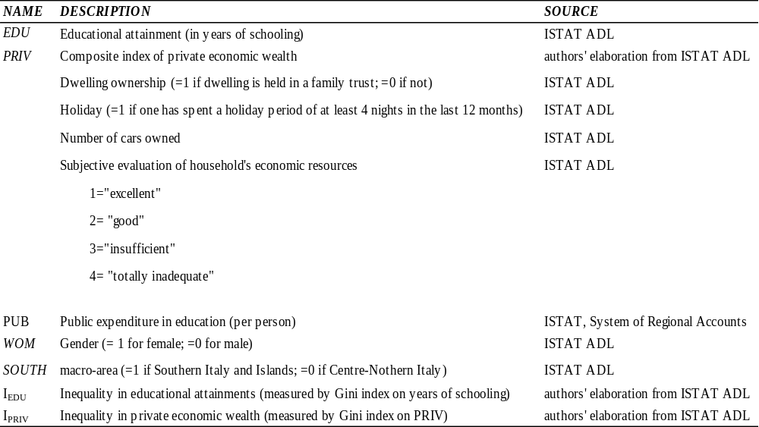
The general formulation and the steps carried out for constructing a composite wealth indicator representing private economic wealth can be summarized as follows. Taking into account the variables available in the ADL survey and the economic components of the Pisa Index of Economic, Social and Cultural Status applied in the empirical investigations on the results of the Program for International Student Assessment (OECD, 2005), we firstly identified four variables as proxies of individual wealth status to be included in the MCA: i) dwelling ownership; ii) whether one has spent a holiday period of at least 4 nights in the last 12 months or not; iii) number of cars owned; iv) judgment concerning the economic resources of all household members (categories ranging from “excellent” to “totally inadequate”). We then computed the PRIV variable using the weights obtained from the MCA as the ratio between the factor score on the first axis normalized by the eigenvalue. The main advantage of using MCA to obtain the private economic wealth index is that it enables us to determine which variables are relevant by considering the pattern of relationships among the various categorical variables. In this way, optimal weights are assigned to each variable without making an a priori assumption (e.g. weighting the initial variables equally).
Therefore, PRIV can be expressed as:
7) $PRIV=\frac{1}{K}\sum_{k=1}^{K}{\sum_{j_{k}}^{J_{k}}{W_{j_{k}}^{k}I_{j_{k}}^{k}}}$
where k is the number of dimensions (variables) with k=(1,2,…K=4), j the number of modalities of each dimension with j=(1,2,… J) and I the binary (0/1) indicator of each modality. According to the above expression, the PRIV variable can be viewed as the average across dimensions (variables) of the weighted sum of each binary modality of each dimension. Lastly, we referred to the min-max approach to obtain PRIV ranging between 0 and 1.
The variable PUB is expressed by government final consumption expenditure for education (per capita) and includes wages, salaries and employees’ social contributions e.g. teachers, as well as capital investments, e.g. infrastructures. This indicator enables us to quantify how much regions spend on improving educational structures and encouraging teachers and students to take part in training programmes.
In order to measure the degree of educational inequality, expressed by the variable I_{EDU} and in private economic wealth, measured by the variable $I_{PRIV}$, we employed the Gini index, which has been increasingly used by several authors to assess educational inequality (Meschi and Scervini, 2013; Checchi, 2001; Thomas et al., 2001), even if earlier studies computed it by using the attainment level proposed by Barro and Lee (2001). The Gini index has been widely used in economic inequality literature thanks to its important advantages: it is scale-invariant; it is bounded between 0 and 1 and can also be defined for zero values of the relevant variable. Therefore, individuals with no formal education could also be included. In addition, the Gini index is an appropriate measure for assessing the private economic wealth inequality expressed by the composite indicator PRIV obtained using the MCA.
More specifically, we measured educational inequality I_{EDU} and inequality in private economic wealth $I_{PRIV}$ using the Gini index for each region and year considered in our analysis. Therefore, the Gini indexes are computed using the following formula:
8) $I_{EDU}=1+\frac{1}{N_{jt}}-\frac{2}{{\overline{EDU}}_{jt}N_{jt}^{2}}\sum_{i=1}^{N_{jt}}{\left(N_{jt}-i+1\right){EDU}_{i}}$
where i identifies the rank of every individual in the total $N_{jt}$ population of region j (j=1,…19) at time t (t=1,…19) and ${EDU}_{i}$ is the amount of education (in years) for individual i in region j at time t. Similarly, in order to compute the Gini index for variable PRIV we used the following formula:
9) $I_{PRIV}=1+\frac{1}{N_{jt}}-\frac{2}{{\overline{PRIV}}_{jt}N_{jt}^{2}}\sum_{i=1}^{N_{jt}}{\left(N_{jt}-i+1\right){PRIV}_{i}}$
After having calculated these variables for all of the individuals included in our pooled dataset, we referred to the pseudo-panel approach according to which individuals sharing some common characteristics (i.e. year of birth) are grouped into cohorts. The averages within these cohorts were then treated as observations in a pseudo-panel data set. From a statistical methodological perspective, this is equivalent to an instrumental variable approach where the grouping indicators are used as instruments (Verbeek, 2008), thus enabling us to obtain an original database which combines temporal, geographical and individual dimensions.
When constructing a pseudo-panel, there is a trade-off between the need to have a large number of observations per cohort and the desire to obtain as much informative data as possible. On one hand, a larger number of cohorts and hence of data points increases the heterogeneity of the pseudo-panel by increasing the variations between groups; on the other, it reduces the average number of individuals per cohort thus resulting in less precise estimates of the cohort means (Baltagi, 2005). As shown by Verbeek and Nijman (1992), measurement error becomes negligible when cohort sizes are large (at least over 100 individuals) and the time variation in the cohort means is sufficiently large.
In order to ensure that the cohort means of the variables based on the sample are reasonable estimates of the population cohort variables, we based the construction of the pseudo-panel on the year of birth and the region in which the respondents reside.
Since we focused on individuals aged 18 or over and considered 19 repeated cross-sections, we defined 9 age cohorts (1921-1926, 1927-1932, 1933-1938, 1939-1944, 1945-1950, 1951-1956, 1957-1962, 1963-1968, 1969-1975) and considered the Italian regions included in the ISTAT survey. Thus by crossing years of birth and regions we obtained 171 groups which generated 3249 observations (i=1…., 171; t=1…., 19; n=3249) over 19 years. In this way, we constructed a series of means of the variables included in the data set and included them in our models by considering the individuals belonging to the same birth cohort from 1993 to 2012.
5. Results
5.1 The evolution of educational attainments and inequality
Figure 1 shows the trend of years of schooling in Italy during the 1993-2012 period. Over the two decades, the average years of schooling increased by roughly 1.5 years, from a base value of approximately 8 years. The Southern educational gap decreased from 1993 to 1997, while it remained stationary in the following period at approximately 1 year of education. It is worth noting that the economic crisis appears to have exacerbated the educational divide between the Centre-North and the South. Figure 2 shows the Gini indices of the years of education for the 1993-2012 period by considering the two Italian macro-areas.
Despite the overall reduction of educational inequality, the dispersion of educational attainment still varies between the Centre-North and the South, with the latter showing higher levels of educational inequality over the period under study. These differences may be due to heterogeneous use of resources and educational policies.

Figure 1 The educational gap between the Centre-North and South of Italy, 1993-2012.

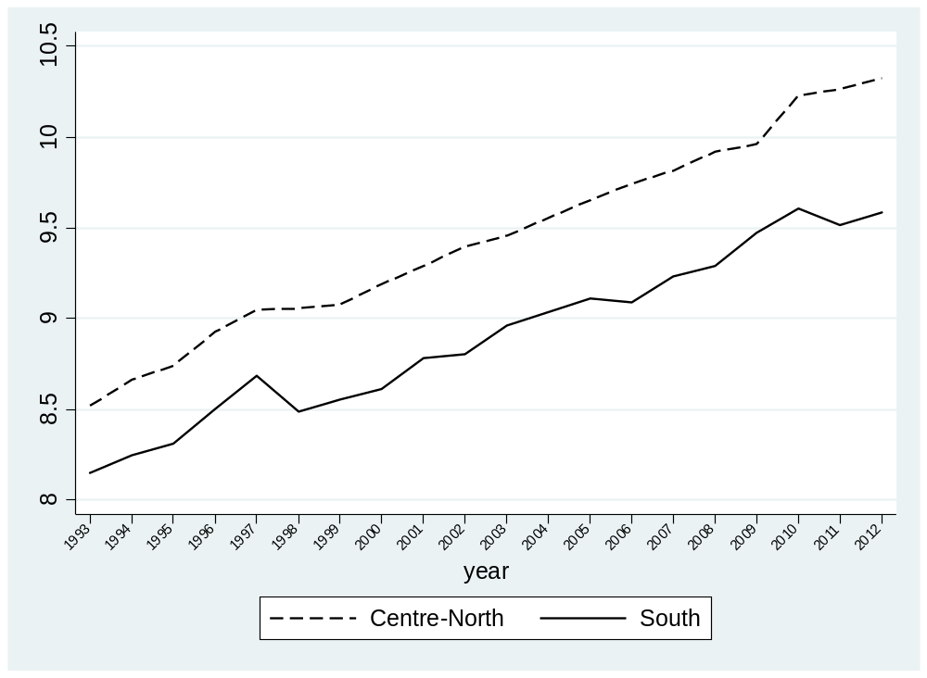

Figure 2 The evolution of the educational Gini index in the Centre-North and South of Italy, 1993-2012

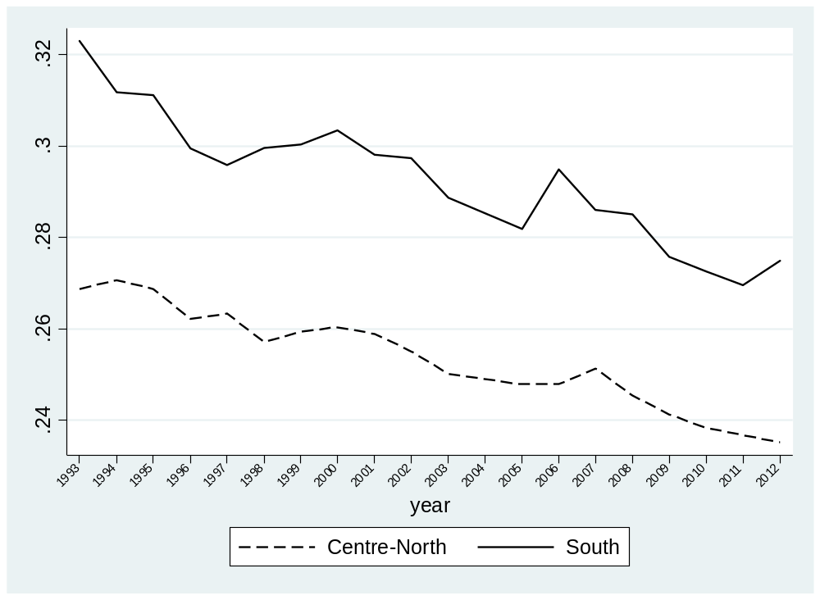
Figures 1 and 2 highlight the expansion of educational attainment that occurred over the study period and the simultaneous decrease in educational inequality except for the South of Italy in 2011-2012.
Table 2 presents 5-year averages of educational attainment and inequality, as measured by the Gini index for 1993-1997, 1998-2002, 2003-2007 and 2008-2012. On average, since 1993 educational attainment has increased across regions even if with different growth rates.
In the last five-years (the 2008-2012 period), the highest levels of the Gini index were in Marche for the Centre-North and Basilicata for the South, while the least “unequal” regions in educational attainments were observed in Trentino-Alto Adige, Piemonte-Valle d’Aosta and Lombardia (see Table 2).

Table 2- Summary statistics of educational attainments and inequality: average values of Italian regions
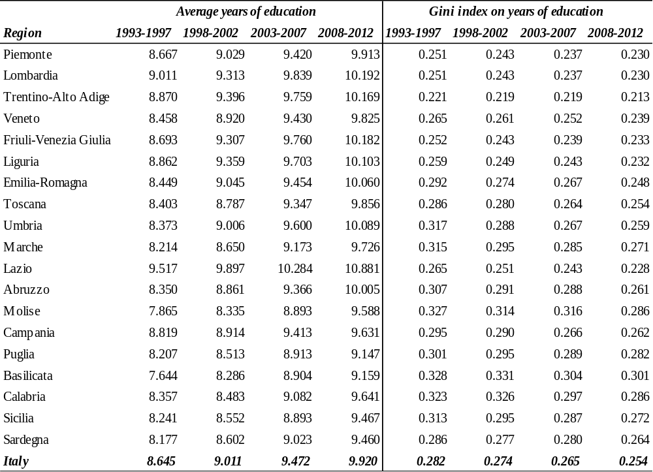
Source: authors’ elaborations from ISTAT database.

Figure 3 shows the nonlinearity in the relationship between educational attainment and inequality although with different dynamics over time. More specifically, educational levels became more unequal in most of the Italian regions with a higher average number of completed years of schooling, which rose to 9-10 and then started to level off. Appendix A provides summary statistics and correlation analysis concerning all of the variables used in our study.

Figure 3 Average years of education vs. educational Gini index in Italian regions, 1993-2012
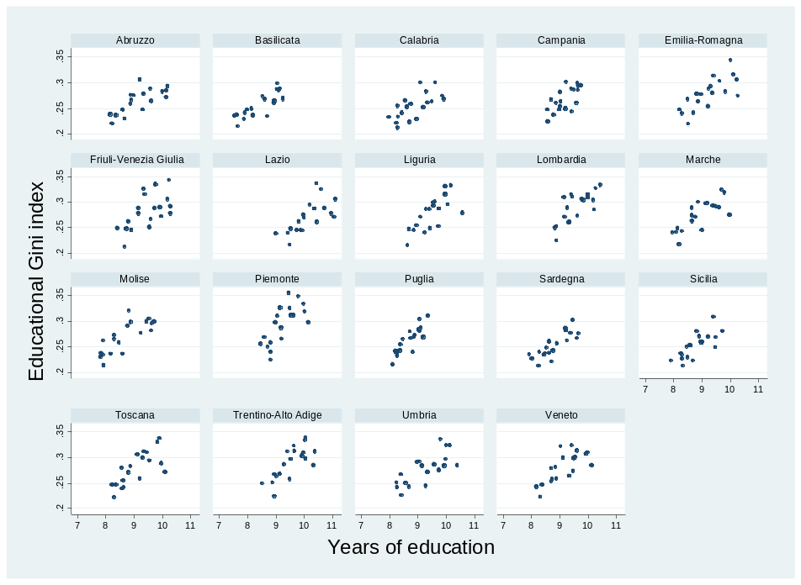
Source: authors’ elaborations from ISTAT database.

5.2 Econometric analysis
Table 3 shows all of the estimates concerning the analysis of the educational gap between the Centre-North and South of Italy obtained using OLS models separately for Centre-North, South and all of the Italian regions. These estimations were the starting points for the Oaxaca-Blinder decomposition which calculated the endowment and coefficient effects. The OLS regressions showed that all resources are relevant for educational performance. The coefficient of the interaction variable PRIV*PUB is positive, indicating that public and private resources are complementary for educational improvement. This appears in line with various international empirical studies (Woessman, 2009; Jacobs and van der Ploeg, 2006), according to which public expenditure can stimulate household expenditure especially for primary and secondary education. Gender educational inequality is significant mainly in the South of Italy; indeed, the coefficients of the variable WOM are all negative. In particular the coefficient for the South of Italy is twice as strong as the coefficient for the Centre-North, which highlights the existence of gender educational inequality. This is a serious issue because education represents a valid instrument for women empowerment both in developing and developed countries or areas such as the South of Italy (Medel-Anonuevo, 1995). Indeed gender educational inequality impacts negatively both on economic growth by increasing the economic gap (Baliamoune–Lutz and McGillivray, 2015) and on gender empowerment regarding the conciliation between career and marriage (Courtioux and Lignon, 2016). Finally, regional dummies are significant thus showing the importance of the “environmental factors” underlying the educational conversion process.
The Oaxaca-Blinder decomposition method obtained the following relevant and diversified results. The educational gap is significant and depends not only on the endowment effect, but also on the coefficient effect. As regards the allocation of private resources, the Centre-North of Italy holds more economic endowment, yet the Southern economic background is more crucial: indeed, the difference between the coefficients is negative, because the Southern coefficient is higher than the Centre- Northern coefficient (namely, given the same level of private economic wealth, the educational returns of the South are higher than those of Centre-North). This verifies at regional level what other studies found at school level, that is the socioeconomic context in the Southern regions has an higher educational impact than in the rest of Italy (Checchi 2004; Bratti 2004; Quintano et al. 2009). This stronger relationship between private economic endowments and educational careers in the South reflects the higher number of resilient students (namely students from underprivileged families but with high educational performance) in the Centre-North. These results stress that in the South the phenomenon of “school tracking” (the types of schools -comprehensive schools, technical and vocational schools- are segmented between wealthy and poor) is more common and this is detrimental for equality of opportunities and earnings in the labour market (Brunello and Checchi, 2007) and for educational equality (Hanushek and Wößmann, 2006). As regards public expenditure per capita in education, the educational gap appears to depend on the quality and use rather than on scarce funding: namely, the endowment difference is negative (in favour of the South), while the coefficient difference is positive (in favour of the Centre-North). From a general perspective, this result is in line with the previous studies on the effectiveness of public resources according to which educational performance is strongly linked with the way public resources are employed (Hanushek, 1994; Hanushek et al., 1996). This empirical evidence is consistent with the lower number of early school leavers (that influence the years of schooling negatively) and higher student competence achievement in the Centre-North (that supports the increase of the percentage of tertiary students) (Table A.2). This kind of results reflect the quality of public expenditure: for instance investments in regional training courses reduce the early school leaver phenomenon by offering alternatives to the standard school courses; on the other hand, investments in the quality of school courses as well as in the tutorial activities for tertiary students may reduce the number of university leavers. Moreover, the Southern regions have fewer early years schools, while the effectiveness of public expenditure in terms of school career is mainly concentrated in the first years of education (Arcalean and Schiopu 2010; OECD, 2011). In this direction, the two results regarding public and private resources form a vicious circle: the South has fewer early years schools, but the investment in this kind of school is the most effective way for mitigating economic dependence (Restuccia and Urrutia,2004). The fact that the Centre-North, the most economically advanced Italian area, attains the most effective public expenditure confirms studies according to which efficiency of public expenditure influences the economic returns of education in the long term (Lu, 2017).

Table 3 Estimation results on the Southern educational gap.
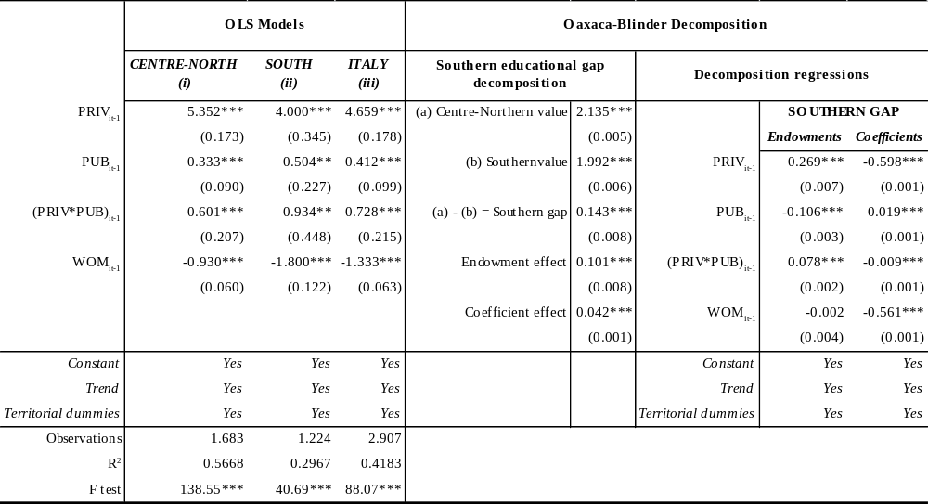
Note: Robust standard errors in parentheses. * p<0.10; ** p<0.05; ***p<0.01, Territorial dummies represent regional dummies in equations (i) and (ii), while in equation (iii) they represent both regional dummies and dummy for South of Italy.

The second part of the empirical analysis is focused on the identification of the factors influencing individual educational inequality in Italy. The presence of an Educational Kuznets Curve for Italy in the 1993-2012 period was tested using a system GMM estimator (Roodman, 2009). Interesting results can be seen in Table 4. Firstly, individual educational inequality is path dependent: the coefficient of the lagged educational Gini index is positive. This result illustrates a divergent social process that precludes social mobility thus weakening the relationship between social progress and economic development (Guarini at al., 2016).
Secondly, there seems to be a strong link between economic and educational inequality: the coefficient of inequality of individual economic wealth (I_{PRIV}) is significant and positive. Moreover, this link is exponential: the coefficient of the square of individual wealth is positive and statistically significant. This result illustrates a socioeconomic trap: inequality in private economic wealth turns into inequality in social opportunities (Lauer, 2003). Thirdly, public expenditure in education seems to be an effective instrument of equity. Its impact on individual educational inequality is negative, even if it is reduced with the increase in public expenditure. This pattern may indicate that the share of public expenditure for tertiary education increases according to the total educational public expenditure which may generate a decreasing educational equality impact in a European country like Italy with medium-low levels of education. From an analytical point of view, the coefficient of the variable PUB is significant and negative, while the coefficient of the variable PUB² is significant and positive: the general estimated function is a parabola, but with the minimum value (equal to .727) outside the range of data of the logarithmic variable PUB (-.524 and .448); therefore the specific function concerning the variable PUB is a decreasing function with decreasing returns. This result for individual inequality in Italy confirms the findings by Lee and De Gregorio (2002) in their cross country analysis and those by Agasisti and Longobardi (2012) at school levels.
Finally, an Educational Kuznets Curve emerges: namely, the coefficients of the variables EDU and EDU² are significantly positive and negative respectively. Therefore, the estimated coefficient on educational attainment and its square are consistent with Figure 3, which shows this empirical evidence at regional level. According to Meschi and Scervini (2013), educational inequality is influenced by an increase of educational average: if the increase is driven by less educated people, inequality decreases, while when it is driven by more educated people, inequality increases. When the educational average is low (high) at absolute terms, the (inverse) Educational Kuznets Curve appears: at the beginning educational improvements favor (decrease) inequality, while after having achieved a maximum (minimum) value of inequality, the relationship becomes negative (positive). Italy attains low values of school years: for instance Italy ranks third to last before Greece and Portugal with respect to the thirty European countries analyzed by Meschi and Scervini (2013) (countries surveys of 13 cohorts each one, from period 1920-1924 to 1980-1984).
This result concerning the Educational Kuznets Curve offers a significant contribution to literature for various reasons: i) it is regional while the other studies are mainly cross-countries with the relevant heterogeneity concerning the educational systems that can influence the results; ii) it measures educational inequality using the Gini index while some studies obtain the Educational Kuznets Curve by applying the standard deviation (Ram 1990; Thomas et al. 2001; De Gregorio and Lee 2002) or they measure the inequality of estimated returns of schooling (Morrison and Martin 2013 and Lim et al., 2008); iii) unlike other studies, we included specific control variables, namely private economic wealth, public resources and gender variables, which according to Meschi and Scervini (2014, 2013) and Benaabdelaali et al.(2012) are essential for educational inequality; iv) finally, our analysis of Educational Kuznets Curve takes directly into account potential simultaneous endogeneity issues (thanks to the dynamic GMM estimator), in contrast with the majority of the abovementioned analyses.

Table 4 Estimation results for individual educational inequality in Italy
Dynamic panel-data estimation, one-step system GMM
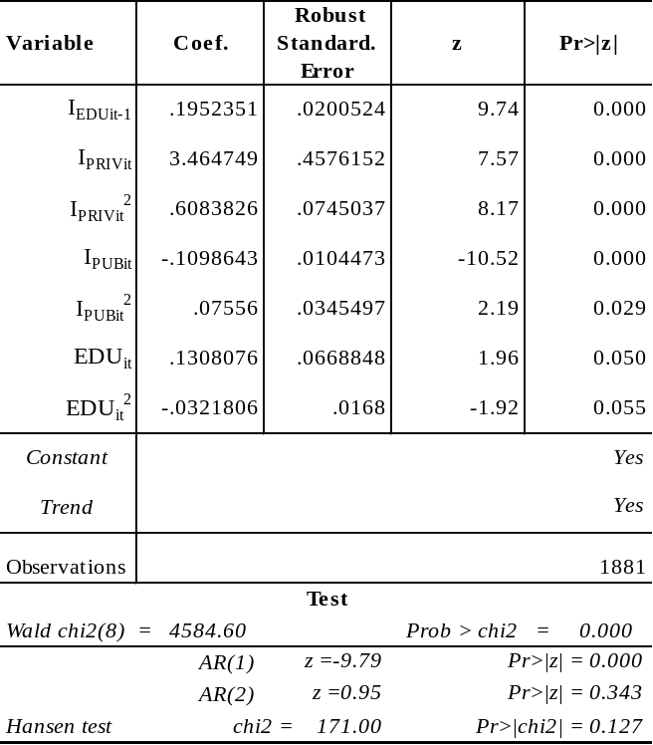

5.3 Robustness checks
Appendix B shows the robustness checks of the abovementioned analysis concerning the Southern educational gap that confirm our results reported in Table 3. By referring to other studies focused on educational performance we controlled for the effect of age by defining cohorts of our pseudo panel according to the year of birth and the region in which individuals reside. In addition, we tested if the inclusion of variable age may affect the results. Table B.1 shows the Oaxaca-Blinder decomposition, that includes age (variable AGE, expressed in years and obtained from ISTAT ADL) in addition to the other variables. This analysis provides similar results to those listed in Table 3, thus confirming that the “age” effect is already considered in our analysis.
We carried out a robustness check by considering individuals aged 30 years and over in order to verify if the results from the Oaxaca-Blinder decomposition change when applied to a sub-sample of individuals who have completed education. Table B.2 reports the results of this analysis. As can be noticed, the results of this additional analysis confirm our main findings. According to other Italian regional studies (Ciriaci 2001; Cannari et al. 2012), in order to take into account regional heterogeneity within each of the two Italian macro-areas (Centre-North and South) we included regional dummies in our models. With the aim of testing the robustness of this procedure, the Gelbach decomposition was carried out (Gelbach, 2016; Cardoso, 2016).As shown in Table B.3, according to this method, four kinds of pooled OLS equations were estimated: the “basic equation” (eq. a) without dummies and three “full equations” namely with regional dummies (eq. b), with cohort dummies (eq. c) and with both regional and cohort dummies (eq. d). Using the Gelbach decomposition, we tested if the Southern educational gap (captured by the coefficient of SOUTH dummy) was influenced by introducing specific fixed effects. In other words, this kind of decomposition enabled us to evaluate the significance of the difference between the coefficients of dummy SOUTH in the base equation and in the full equation and whether this difference was affected by introducing fixed effects. According to the results, regional dummies significantly influenced the Southern educational gap, both alone and together with cohort dummies, while cohort dummies were not significant when introduced alone. Therefore, this last check corroborates the introduction of territorial fixed effects in the Oaxaca-Blinded decomposition.

6. Concluding remarks and policy implications

In this paper, we developed an empirical analysis aimed at investigating educational attainment and inequality in Italy between Centre-Northern and Southern areas and across individuals in the 1993-2012 period using a database constructed from the ISTAT ADL survey. We applied the Amartya Sen’s Capability Approach, according to which public and private resources can be “converted” into individual or collective educational achievements such as years of education. This “conversion” may be represented by a function whose input variables are individual economic wealth and public expenditure in education, as well as “conversion” factors (namely, elements that influence individual or community conversion) such as gender and territory. Through the econometric estimation of this conversion function, by implementing the Oaxaca-Blinder decomposition method, we found that the educational achievement process is strongly and positively influenced by private economic wealth and public resources that seem to be complementary. Moreover, we found that educational achievements are relatively more difficult for females. The educational gap between the Centre-North and the South is mainly affected by the relative ineffectiveness of public expenditure in the South of Italy, even if there are more available funds in the South than in the Centre-North. The lower level of private economic wealth also affects the gap, even if its effect is stronger in the South than in the Centre-North. The GMM estimator produced interesting results concerning individual inequality, which appears to be path dependent and strongly linked to economic inequality. Furthermore, public expenditure per capita in education seems to be an effective instrument for promoting educational equality. We also obtained an Educational Kuznets Curve that indicates an inverted U-shaped relationship between educational attainment and inequality.
The article presents original findings. For the first time in literature, we constructed a micro-data set using the ADL survey for the 1993-2012 period and computed educational attainment at individual level and educational inequality measures at regional level. More specifically, this paper shows novel empirical evidence on monitoring long-term Italian social progress by constructing specific measures: an educational Gini index, a private economic wealth index and a Gini index of individual economic wealth. Moreover, it proposes an innovative analysis of the educational gap between the Centre- North and the South using the Oaxaca-Blinder method, which is generally used to analyse social group differences (such as sex, ethnic groups). This article also provides an original dynamic panel analysis concerning the Educational Kuznets Curve. Finally, we focused on territory as an important conversion factor. This focus is coherent with the theoretical framework of Capability Approach in which the individual is not a monad, but interacts with others and with the environment, even if this topic is seldom analysed in empirical studies on the Capability Approach and in educational economic literature where empirical evidence mainly concerns micro data at school level. Therefore, territorialisation of the Capability Approach is a new promising empirical research field as illustrated by Biggeri and Ferrannini (2014).
Relevant political implications emerge from our econometric results. Institutions should strive to achieve a socially optimal combination of national and local educational drivers in order to sustain the two main pillars of the educational system: quality of provision and equality of access. As highlighted in many studies (Singh, 2014), educational equality is strongly linked to social, economic and gender equality. Indeed, educational inequality may generate a multidimensional trap which may become permanent without sound public interventions to eliminate the roots of marginalisation (Bourguignon et al. 2007; World Bank, 2006; Marrero a Rodríguez, 2013; UNESCO, 2013). Therefore the empirical results corroborate the importance of the European Union efforts for educational inclusion (Hippe et al., 2016). In synthesis, the main policy implications of the study are two: to promote universal access to the educational system which can break the link between economic and educational inequality and to implement institutional mechanisms with the aim of evaluating the educational returns of public expenditure. Concerning this last point, results showing that there are different educational performances of public expenditure in terms of years of education, corroborate empirically the framework of the cohesion policies promoted by the European Union (Barca, 2009; Solly 2016) namely: the development of a culture of evaluation and accountability by using targets such as those in the Europe 2020 Strategy; the introduction of reward and penalization mechanisms to incentivize efficiency at various institutional levels; the implementation of pilot projects to find benchmarks and critical factors. In the perspective of the place-based policies, territory is not only a beneficiary of educational investment, but it is also responsible for the management of these resources. Furthermore, given the existence of an Educational Kuznets Curve in Italy, public actions to reduce early school leavers and to increase the tertiary students should be complementary and part of the same national educational strategy (European Commission, 2013b), otherwise educational inequality may be exacerbated.
In conclusion, as pointed out by Checchi et al. (2016), empirical studies on education provide more detailed information on inequality, which would make redistributive initiatives more acceptable for citizens and they may stimulate further studies on educational inequality in specific social subgroups, for which more effective public interventions are required.
References
Agasisti, T., Longobardi, S., 2012. Can Italian disadvantaged students close the gap? A focus on resilience in the Italian school system. IEB Working Paper
Aghion, P., Caloli, E., Garcia-Penalosa, C., 1999. Inequality and Growth: The Perspective of New Growth Theories. J. Econ. Lit. 37 (4), 1615–1660.
Arcalean, C., Schiopu, I., 2010. Public versus private investment and growth in a hierarchical education system. J. Econ. Dyn. Control. 34 (4), 604-622.
Arellano, M., Bond, S., 1991. Some tests of specification for panel data: Monte Carlo evidence and an application to employment equations. Rev. Econ. Stud. 58 (2), 277-297.
Baliamoune–Lutz, M., McGillivray, M., 2015. The impact of gender inequality in education on income in Africa and the Middle East. Econ Model. 47, 1–11.
Ballet, J., Dubois, J.L., Mahieu, F., 2007. Responsibility for Each Other's Freedom: Agency as the Source of Collective Capability. J. Hum. Dev. Capab. 8 (2) ,185-201.
Baltagi, B.H., 2005. Econometric Analysis of Panel Data John, 3rd ed. Wiley & Sons Ltd, West Sussex, England.
Bank of Italy, 2014. The economy of the Italian regions. Short-term dynamics and structural features. Regional Economies 43.
Barca, F., 2009. An agenda for a reformed cohesion policy: A place-based approach to meeting European Union challenges and expectations. Independent Report prepared at the request of Danuta Hübner, Commissioner for Regional Policy, April 2009. Brussels: EU Commission.
Barro, R., Lee, J.W., 2001. International Data on Educational Attainment: Updates and Implications. Oxf. Econ. Pap. 53(3), 541–563.
Becchetti, L., Massari, R., Naticchioni, P., 2014. The drivers of happiness inequality: suggestions for promoting social cohesion. Oxf. Econ. Pap. 66 (2), 419–442.
Becker, G., 1993. Human capital: a theoretical and empirical analysis, with special reference to education. Chicago: University of Chicago Press.
Benaabdelaal W., HanchaneS., Kamal A. (2012), Educational Inequality in the World, 1950–2010: Estimates from a New Dataset. in John A. Bishop, Rafael Salas (ed.) Inequality, Mobility and Segregation: Essays in Honor of Jacques Silber 337-366, Emerald Group Publishing,Bingley, UK.
Bertola, E., Sestito, G., 2011. A Comparative Perspective on Italy’s Human Capital Accumulation, Quaderni di Storia Economica (Economic History Working Papers), no. 6 – October.

Biggeri, M., Ferrannini, A., 2014. Sustainable Human Development A New Territorial and People-Centred Perspective. Palgrave-MacMillan.
Blinder, A.S., 1973. Wage Discrimination: Reduced Form and Structural Estimates. Journal of Human Resources, 8 (4), 436–455.
Blundell, R., Bond, S., 1998. Initial conditions and moment restrictions in dynamic
panel data models. J. Econom. 87 (1), 115-43.
Booysen, F., Van Der Berg, S., Burger, R., Von Maltitz, M., and Du Rand, G., 2008. Using an asset index to assess trends in poverty in seven Sub-Saharan African countries. World Dev. 36 (6), 1113-1130.
Bourguignon, F., Ferreira, F. H., Walton, M., 2007. Equity, efficiency and inequality traps: A research agenda. J. Econ. Inequal. 5 (2), 235–256.
Bratti, M., Checchi, D., Filippin, A., 2007. Geographical Differences in Italian students’ mathematical competencies: Evidence from PISA 2003. GdE 66 (3), 299-333.
Brunello, G., Checchi, D., 2007. Does school tracking affect equality of opportunity? New international evidence. Econ. Policy. 22 (52), 781–861.
Brunello, G., Comi, S., 2004. Education and earnings growth: evidence from 11 European countries. Econ Educ Rev. 23 (1), 75-83.
Cannari, L., Franco, D., 2010. Il Mezzogiorno e la politica economica dell’Italia. Bank of Italy, Workshop and Conferences No.4 June.
Cannari, L., Magnani, M., Pellegrini, G., 2012. Quali politiche per il Sud? Il ruolo delle politiche nazionali e regionali nell'ultimo decennio. Bank of Italy Occasional Papers No.50.
Cardoso, A. R., Guimarães, P., Portugal, P., 2016. What drives the gender wage gap? A look at the role of firm and job-title heterogeneity. Oxf. Econ. Pap. 68 (2), 506–524.
Castello-Climent, A., 2010. Inequality and Growth in Advanced Economies: An Empirical Investigation. J. Econ. Inequal. 8, 293–321
Castellò, A., Domenech, R., 2002. Human capital inequality and economic growth: some new evidence. Econ. J. 112 (478), 187-200.
Charron, N., Dijkstra, L., Lapuente, V., 2015. Mapping the regional divide in Europe: A measure for assessing quality of government in 206 European regions. Soc. Indic. Res. 122 (2), 315-346.
Checchi, D., 2001. Education, Inequality and Income Inequality. LSE STICERD Research Paper No. 52.
Checchi, D., 2004. Da dove vengono le competenze scolastiche? L’indagine PISA 2000 in Italia. Stato mer. 77 (3), 413-454.
Checchi, D., Peragine, V., 2010. Inequality of opportunity in Italy. J. Econ. Inequal. 8, 429–450.
Checchi, D., Peragine, V., Serlenga, L., 2016. Inequality of Opportunity in Europe: Is There a Role for Institutions? in Cappellari, L., Polachek, S.W., Tatsiramos ,K., (ed.) Inequality: Causes and Consequences Research in Labor Economics (43) 1–44, Emerald Group Publishing Limited.
Chiappero-Martinetti, E., Salardi, P., 2008. Well-being process and conversion factors: an estimation. HDCP-IRC Working Paper Series No.3, Human Development, Capability and Poverty International Research Centre.
Ciriaci, D., 2001. Convergenza e dualismo: Nord e Sud tra il 1970 e il 1999. Riv. econ. Mezzogiorno 4, 763-803.
Collado, M. D. (1997). Estimating dynamic models from time series of independent cross-sections. J. Econom. 82 (1), 37-62.
Courtioux, P., Lignon, V., 2016. A good career or a good marriage: The returns of higher education in France. Econ Model. (57), 221-237
Denuelin, S., Shahani, L., 2009. An Introduction to the Human Development and Capability Approach, Earthscan, IDRC, London.
Dang, H.A., Lanjouw, P., Luoto, J., McKenzie, D., 2014. Using repeated cross-sections to explore movements into and out of poverty. J. Dev. Econ. 107, 112–128.
Deaton, A., 1985. Panel Data from Time Series of Cross Sections. J. Econom. 30, 109–126.
De Gregorio, J., Lee, J.W, 2002. Education And Income Inequality: New Evidence From Cross-Country Data. Rev. Income Wealth 48 (3), 395-416.
Deininger, K., Squire, L., 1998. New ways of looking at old issues: inequality and growth, J. Dev. Econ. 57 (2), 259–87.
De Simone, G., 2013. Render unto primary the things which are primary’s: Inherited and fresh learning divides in Italian lower secondary education. Econ. Educ. Rev. 35, 12–23.
Dissou, Y., Didic, S., Yakautsava, T., 2016. Government spending on education, human capital accumulation, and growth, Econ. Model. 58, 9–21.
Dosi, G., Freeman, C., Nelson, R., Silverberg, G., Soete, L., 1988. Technical Change and Economic Theory. London and New York, Pinter Publishers.
European Commission, 2013a. Reducing early school leaving: Key messages and policy support. Final Report of the Thematic Working Group on Early School Leaving. Education and training.
European Commission, 2013b. Education and Training in Europe 2020: Responses from the EU Member States. Eurydice Report. Brussels: Eurydice.
European Commission, 2016. European Semester: Thematic factsheet – Tertiary education attainment.
Evans, P., 2002. Collective capabilities, culture and Amartya Sen’s development as freedom. Stud. Comp. Int. Dev. 37(2), 54–60.
Felice, E., Vasta, M., 2014. Passive Modernization? The New Human Development Index and Its Components in Italy's Regions (1871-2007). Eur. Rev. Econ. Hist. 19 (1), 44–66.
Fukumura, K., 2017. Effects of education externalities on schooling Econ. Model. 60, 39-50.
Galor, O., 2009. Inequality and Economic Development: An Overview. Brown University, Department of Economics Working Paper No.3.
Garcia-Penalosa, C.,1994.Inequality and Growth: A Note on Recent Theories. Investigaciones Económicas 18 (1), 97–116.
Gelbach, J.B., 2016. When do covariates matter? And which ones, and how much?. J. Labor Econ. 34 (2), 509-543.
Girma, S., 2000. A quasi-differencing approach to dynamic modelling from a time series of independent cross-sections. J. Econom. 98 (2), 365-383.
Green, W., 2012. Econometric Analysis, Pearson Education, Boston USA.
Guarini, G., 2009. Labour productivity and technological capability: an econometric analysis on the Italian regions. in Neri Salvadori (ed.), Geography, Structural Change and Economic Development: Theory and Empirics, Edward Elgar, Cheltenham, 280-303.
Guarini, G., Molini, V., Rabellotti, R., 2006. Is Korea Catching Up? An Analysis of the Labour Productivity Growth in South Korea. Oxf. Dev. Stud. 34 (3) 323-339.
Guarini, G., Laureti T., Garofalo, G., 2016. Cultura, sviluppo economico e mobilità sociale in Italia: gli squilibri territoriali. Ec. cultura 1 ,133-148.
Hanushek, E., Wößmann, L., 2006. Does educational tracking affect performance and inequality? Differences-in-differences evidence across countries. Econ. J. 116 (510), 63–76.
Hanushek, E., A., 1994. Money Might Matter Somewhere: A Response to Hedges, Laine, and Greenwald. Edu. Res. 23 (4), 5-8.
Hanushek, E. A., Rivkin, S. G., Taylor, L.L., 1996. Aggregation and the Estimated Effects of School Resources, Rev. Econ. Stat. 78 (4), 611-627.
Hanushek, E. A., 1997. Assessing the Effects of School Resources on Student Performance: An Update. Educ. Eval. Policy Anal. 19 (2), 141-164.
Hanushek, E. A., 2002. Publicly Provided Education. Handb. Pub. Econ. 4 (30), 2043-2141.
Hippe, R., Araùjo, L., da Costa, P.D., 2016. Equity in Education in Europe. European Commission, JRC Technical Report.
Ibrahim, S.S., 2006. From Individual to Collective Capabilities: The Capability Approach as a Conceptual Framework for Self-help. J. Hum. Dev. Capabil. 7 (3), 397-416.
Inoue, A., 2008. Efficient estimation and inference in linear pseudo-panel data models. J. Econom. 142 (1), 449-466.
Iuzzolino, G., Pellegrini, G., Viesti, G., 2011. La convergenza tra le regioni italiane,1861-2011. Economic History Working Papers No.26.
Jacobs, B., van der Ploeg, F., 2006. Guide to Reform of Higher Education: A European Perspective. Econ. Policy. 21 (47) 535-592.
Jalil, A., Idress M., 2013. Modeling the impact of education on the economic growth: Evidence from aggregated and disaggregated time series data of Pakistan. Econ. Model. 31, 383–388.
Jann, B., 2008. The Blinder-Oaxaca decomposition for linear regression models. Stata J. 8 (4), 453-479.
Johnston, R., Burgess, S., Wilson, D., Harris, R., 2006. School and residential ethnic segregation: An analysis of variations across England’s Local Education Authorities. Reg. Stud. 40 (9), 973–990.
Kuklys, W., 2005. Amartya Sen’s Capability Approach. Theoretical Insights and Empirical Applications. Springer, Berlin.
Lall, S., 2001. Competitiveness, Technology and Skills. Cheltenham: Edward Elgar.
Lauer, C., 2003. Family background, cohort and education: A French–German comparison based on a multivariate ordered probit model of educational attainment. Labour Econ. 10 (2), 231–251.
Laureti, T., Secondi, L., Biggeri, L. 2014. Measuring the efficiency of teaching activities in Italian universities: An information theoretic approach. Econ. Educ. Rev, 42, 147-164.
Lien, D., 2006. On the optimal quality of domestic higher education programs. Econ. Model. 23 (2), 265-275.
Lim, A. S. K., Tang, K. K., 2008. Human Capital Inequality and the Kuznets Curve. Dev.Econ. 46 (1), 26-51.
Londoño, J.L., 1996. Inequality and poverty in Latin America during the last four decades. Washington: World Bank Latin American and Caribbean Studies.
Lu, C.H., 2017. Social status, compulsory education, and growth. Econ. Model. https://doi.org/10.1016/j.econmod.2017.08.013.
Lucas, R. E., 1988. On the Mechanics of Economic Development. J. Monetary Econ. 22 (1), 3–42.
Marrero, G. A., Rodríguez, J. G., 2013. Inequality of opportunity and growth. J. Dev. Econ. 104, 107–122.
McKenzie, D.J., 2004. Asymptotic Theory for Heterogeneous Dynamic Pseudo-Panels. J. Econom. 120 (2), 235–262.
Medel-Anonuevo, C., 1995. Women, Education and Empowerment: Pathways towards Autonomy. UNESCO Institute for Education,Colombia.
Melamed, C., Samman, E., 2013. Equity, Inequality And Human Development In A Post-2015 Framework. Research Paper Human Development Report Office, United Nations Development Programme.
Meschi, E., Scervini, F., 2013. Expansion of schooling and educational inequality in Europe: the educational Kuznets curve revisited. Oxf. Econ. Pap. 66 (3) 660–680.
Meschi, E., Scervini, F., 2014. A new dataset on educational inequality. Empir. Econ. 47 (2), 695–716.
Mincer, J., 1974. Schooling, Experience, and Earnings. New York: NBER.
Moffitt, R., 1993. Identification and Estimation of Dynamic Models with a Time Series of Repeated Cross-Sections. J. Econom. 59(1-2), 99–123.
Morrisson, C., Murtin, F., 2013. The Kuznets curve of education: a global perspective on education inequalities, J. Econ. Inequal. 11 (3) 283–301.
Norheim, O.F., Asada, Y., 2009.The ideal of equal health revisited: definitions and measures of inequity in health should be better integrated with theories of distributive justice. Int. J. Equity Health. 8(40), doi:10.1186/1475-9276-8-40.
Nussbaum, M., 2003. Capabilities as fundamental entitlements: Sen and social justice Fem. Econ. 9 (2-3), 33-59.
Oaxaca, R. L., 1973. Male-Female Wage Differentials in Urban Labor Markets Int. Econ. Rev. 14 (3) 693–709.
OECD, 2005. PISA 2003. Technical Report., OECD, Paris Programme for International Student Assessment.
OECD, 2010, PISA 2009 Results: Learning Trends. Changes in Student Performance Since 2000. Volume V, Paris, OECD Publishing.
OECD, 2011. PISA in Focus: does participation in pre-primary education translate into better learning outcomes at school? Paris: OECD Publishing.
Park, K.H., 1996. Educational expansion and educational inequality on income distribution, Econ. Educ. Rev. 15 (1) 51–58.
Quintano, C., Castellano, R., Longobardi, S., 2009. L’influenza dei fattori socio economici sulle competenze degli studenti italiani. Un’analisi multilevel dei dati 28 PISA 2006. Rev. Econ. Stat. Reg. Stud. 2, 109 - 149.
Ram, R., 1990. Educational expansion and schooling inequality: international evidence and some implications. Rev. Econ. Stat. 72 (2) 266–74.
Rambla, X., Langthaler, M., 2016. The SDGs and inclusive education for all. From special education to addressing social inequalities. Briefing Paper n.14, Austrian Foundation for Development Research.
Reheme, G., 2007. Education, Economic Growth and Measured Income Inequality. Economica 74 (295), 493–514.
Restuccia, D., Urrutia, C., 2004. Intergenerational Persistence of Earnings: The Role of Early and College Education. Am. Econ. Rev., 94 (5), 1354-1378
Robeyns, I., 2003. Sen’s Capability Approach and gender inequality: selecting relevant capabilities. Fem. Econ. 9 (2-3), 61-92.
Robeyns, I., 2005. The Capability Approach: a theoretical Survey. J. Hum. Dev. Capab. 6 (1), 93-114.
Robeyns (2006), Three models of education: rights, capabilities and human capital, Theory Res. Educ. 4 (1), 80–83.
Rodriguez-Posè, A., Tselios, V., 2009. Education and income inequality in the regions of the European Union. J. Regional Sci. 49 (3), 411–437.
Roodman, D., 2009. How to Do xtabond2: An Introduction to "Difference" and "System" GMM
in Stata. Stata Journal 9 (1), 86-136.
Sauer, P., Zagler, M., 2014. (In)Equality in Education and Economic Development, Rev. Income Wealth 60 (S2), 353-379.
Sen, A., 1985. Commodities and Capabilities. North Holland, Amsterdam.
Sen, A., 1992. Inequality Re-examined, Oxford University Press, Oxford
Sen, A., 1997. Human capital and human capability, World Dev. 25 (12), 1959–1961
Sen, A., 1999. Development as freedom. Oxford: Oxford University Press.
Serlenga L., 2016. Inequality of Opportunity in Europe: Is There a Role for Institutions?, in Lorenzo Cappellari , Solomon W. Polachek , Konstantinos Tatsiramos (ed.) Inequality: Causes and Consequences, Research in Labor Economics, 43, Emerald Group Publishing Limited,1 - 44.
Shindo, Y., 2010. The effect of education subsidies on regional economic growth and disparities in China”, Econ. Model. 27 1061–1068.
Singh, K., 2014. Right to Education and Equality of Educational Opportunities. J. Int. Coop. 16 (2), 5-19.
Smits, J., Steendijk, R., 2015. The international wealth index (IWI). Soc. Indic. Res. 122 (1), 65-85.
Solly, A., 2016. Place-based innovation in Cohesion Policy: meeting and measuring the challenges. Reg. Stud. Reg. Sci. 3 (1), 193-198.
Stewart F. (2005) Groups and capabilities. J. Hum. Dev. Capab. 6 (2), 185–204.
Terzi, L., 2008. Justice and Equality in Education, Continuum, London
Thomas, V., Wang, Y., Fan, X., 2001. Measuring education inequality: Gini coefficients of education. World Bank Policy Research Working Paper No. 2525, Washington, DC
UNDP, 2017. Human Development for Everyone, The Human Development Report.
UNESCO, 2013. EFA Global Monitoring Report 2013-14: Teaching and Learning: Achieving Quality for All. UNESCO Publishing
UNESCO, 2017. Education for Sustainable Development Goals Learning Objectives, Paris.
Verbeek, M., 2008. Pseudo panels and repeated cross-section in The Econometrics of Panel Data, Adv. Stud. Theoret. Appl. Econometrics. 46, 369-383.
Verbeek, M., Nijman, Th.E., 1992. Can Cohort Data Be Treated As Genuine Panel Data? Empir. Econ. 17, 9–23.
Verbeek, M., and Vella, F., 2005. Estimating dynamic models from repeated cross-sections. J. Econom. 127 (1), 83-102.
Vladimirova, K., Le Blanc, D., 2015. How well are the links between education and other sustainable development goals covered in UN flagship reports? A contribution to the study of the science-policy interface on education in the UN system. DESA Working Paper No. 146
Watson, N., Wooden, M., 2009. Identifying factors affecting longitudinal survey response. In P. Lynn (Ed.), Methodology of Longitudinal Surveys, 157–182. Chichester, UK: Wiley.
Woessmann, L., 2009 Public-private partnerships and student achievement: A cross-country analysis. In: Chakrabarti, R., Peterson, P.E. (Eds.), School Choice International: Exploring Public-Private Partnerships. 13–45, The MIT Press.
World Bank 2006. World Development Report 2006. Equity and development. Washington, DC: The World Bank and Oxford University Press.
Zimmer R., e Toma E., 2000 Peer Effects in Private and Public Schools Across Countries. J. Pol. Anal. Manag. 19 (1),75-92.

Appendix A. Descriptive Statistics
Table A.1 Historical statistics about Southern educational gap
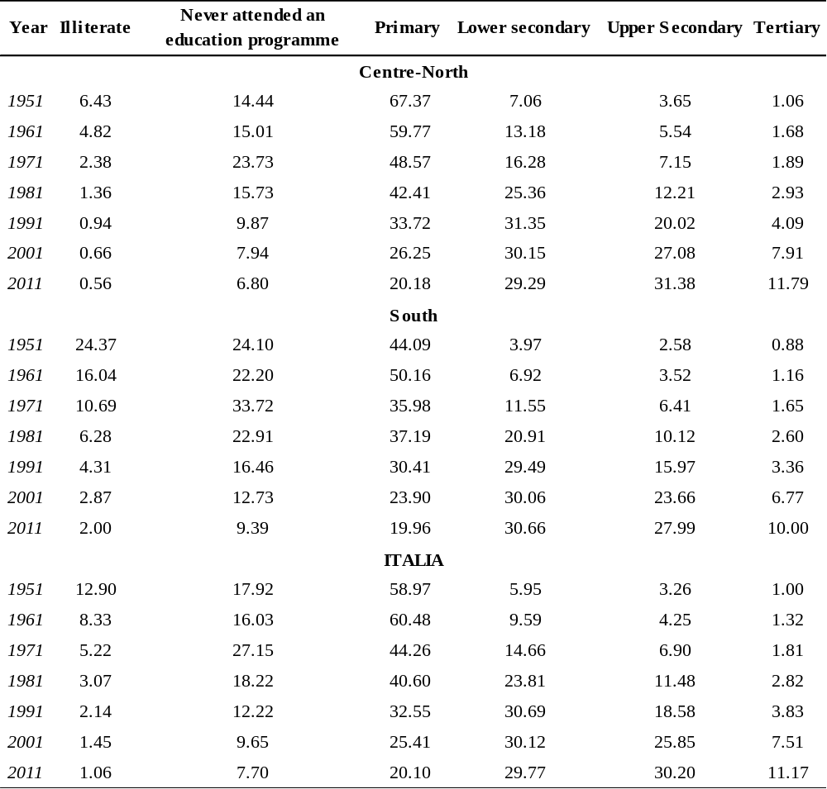
Note: Population by educational attainment level and macro-area of residence (percentage of total population). Source: ISTAT

TableA.2 The Educational targets of Europe 2020 Strategy
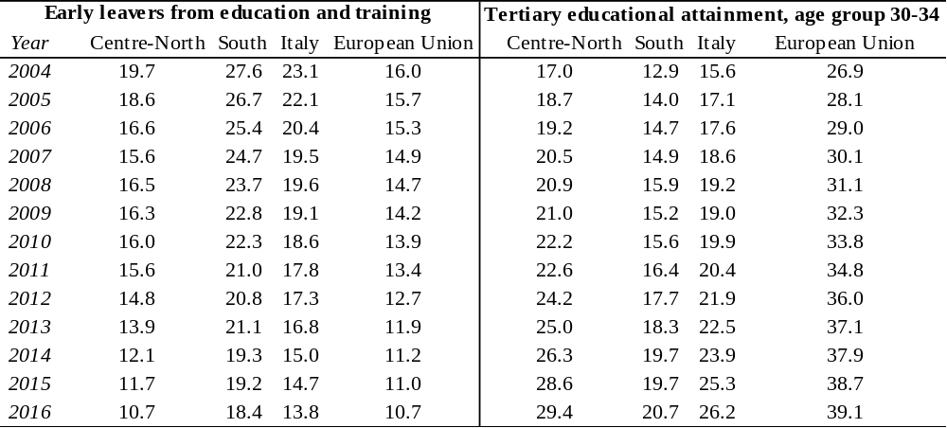
Note: Source Eurostat database. Early leavers from education and training is defined “as the percentage of the population aged 18-24 with at most lower secondary education and who were not in further education or training during the last four weeks preceding the survey. Lower secondary education refers to ISCED (International Standard Classification of Education) 2011 level 0-2 for data from 2014 onwards and to ISCED 1997 level 0-3C short for data up to 2013. The indicator is based on the EU Labour Force Survey”. Tertiary educational attainment, age group 30-34 is defined “as the percentage of the population aged 30-34 who have successfully completed tertiary studies (e.g. university, higher technical institution, etc.). This educational attainment refers to ISCED (International Standard Classification of Education) 2011 level 5-8 for data from 2014 onwards and to ISCED 1997 level 5-6 for data up to 2013. The indicator is based on the EU Labour Force Survey”. Are considered the 28 members of European Union in the 2016.

Table A.3 Summary statistics of variables in equation (5) by geographical areas
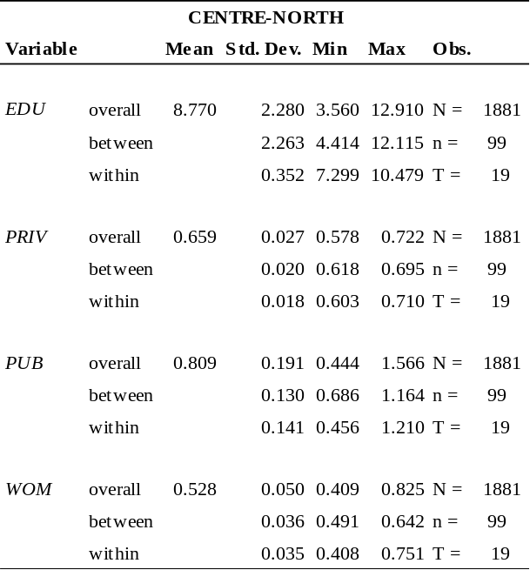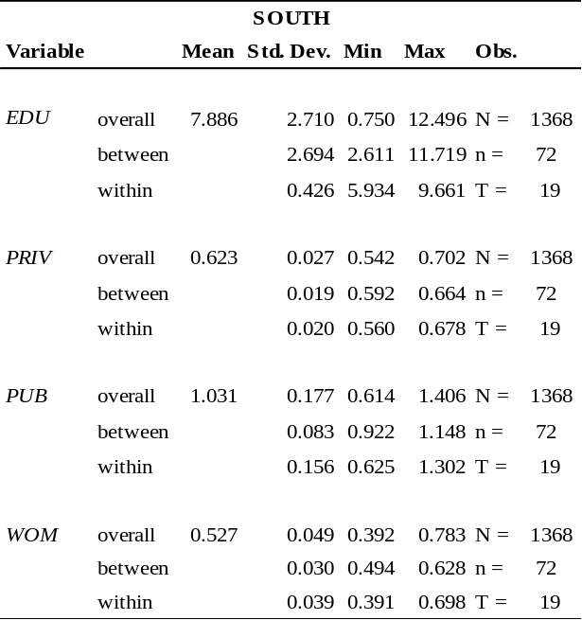
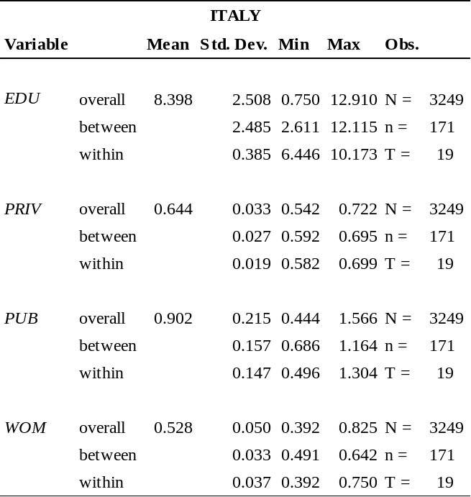

Table A.4 Correlation matrix of variables in equation (5) by geographical areas
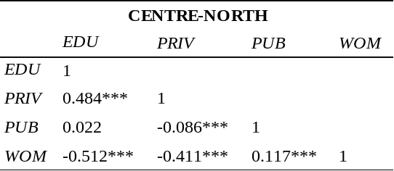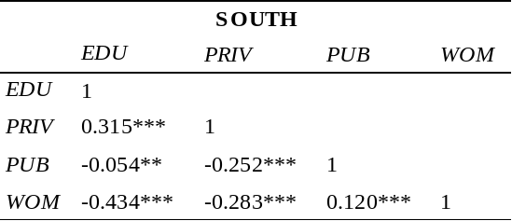
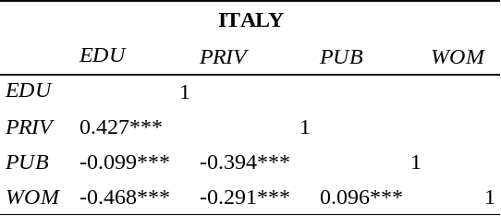
Note: * p<0.10; ** p<0.05; ***p<0.01,
Table A.5 Summary statistics of variables in equation (6)
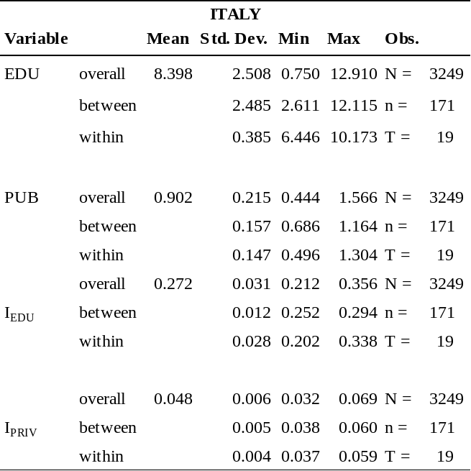

Table A.6 Correlation matrix of variables in equation (6)
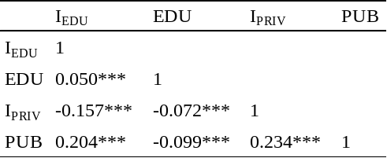
Note * p<0.10; ** p<0.05; ***p<0.01,

Appendix B. Robustness checks
Table B.1 Oaxaca Blinder Decomposition with the introduction of variable AGE
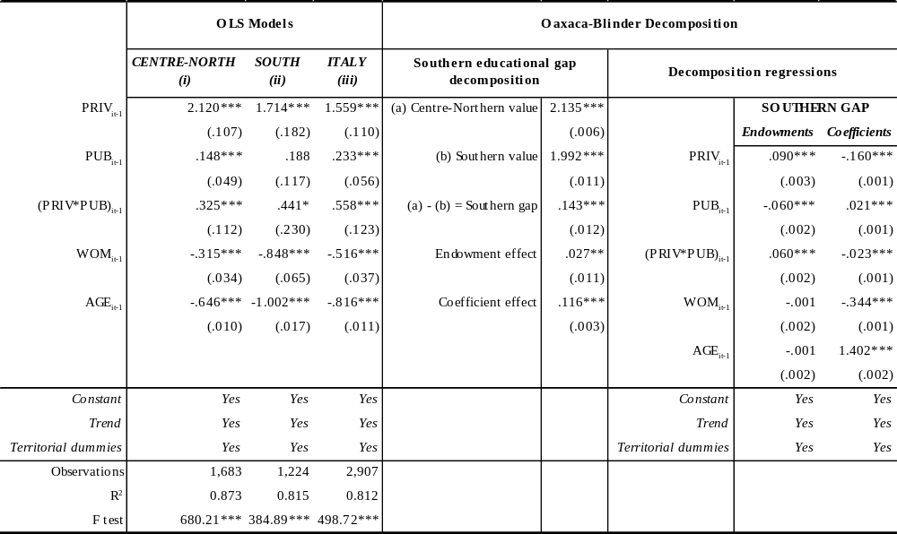
Note: Robust standard errors in parentheses. * p<0.10; ** p<0.05; ***p<0.01, Territorial dummies represent regional Dummies in equations (i) and (ii), while in equation (iii) they represent both regional dummies and dummy for South of Italy.

Table B2. Oaxaca Blinder Decomposition on individuals aged 30 years and over (in average)
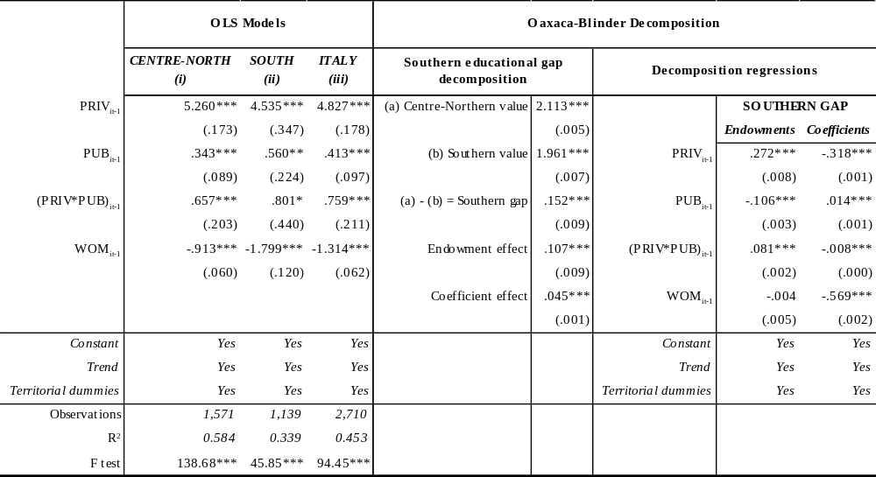
Note: Robust standard errors in parentheses. * p<0.10; ** p<0.05; ***p<0.01, Territorial dummies represent regional Dummies in equations (i) and (ii), while in equation (iii) they represent both regional dummies and dummy for South of Italy.

Table B.3 Gelbach Decomposition
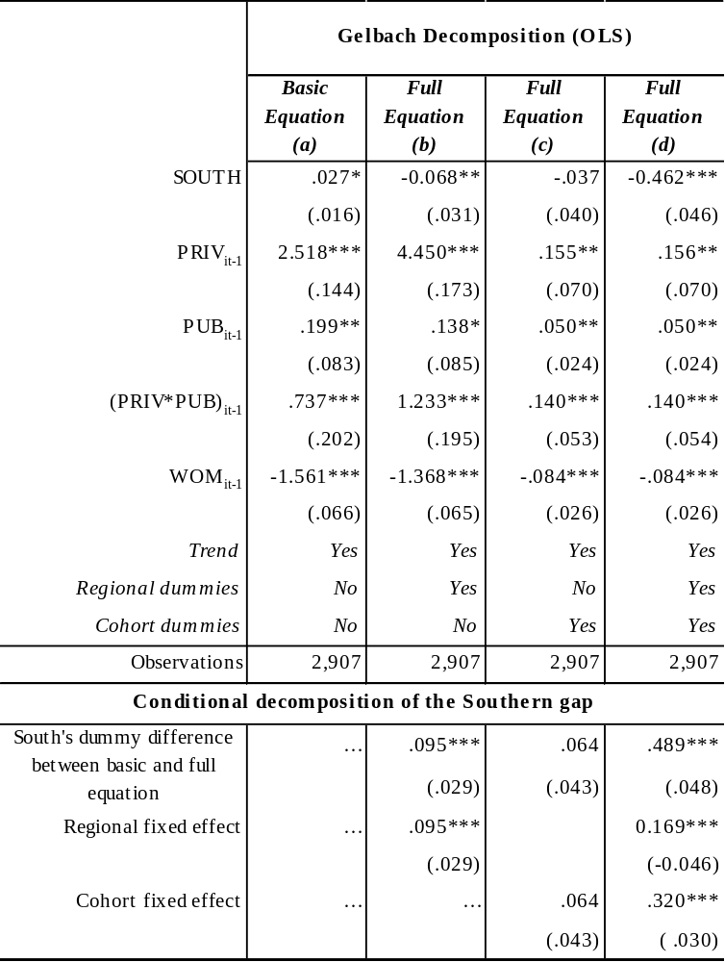
Note: Robust standard errors in parentheses. * p<0.10; ** p<0.05; ***p<0.01,

This study did not receive any specific grant from funding agencies in the public, commercial or not-for-profit sectors. The authors are especially grateful for helpful comments from three anonymous referees and the Editor. Their insightful suggestions enabled us to greatly improve this paper. The usual disclaimer applies.
“In a society where nobody has access to education, the level of education is zero and the variance of education among the population is naturally zero. In a society where the entire population reaches the maximum level of education, the level of education is at the maximum, but the variance, again, is zero […] In the interim period, the variance of education tends to rise with the increase in the level of education until it reaches a turning point, after which it decreases” (Londoño, 1996 p.13).
As stated by Green (2012) this decomposition can be computed at the means of the regressor vectors and the least squares coefficient vectors.
Although repeated cross section data cannot follow the same individuals over time, there are certain advantages in using them rather than genuine panel data. Indeed, like all sample surveys, longitudinal surveys are affected by non-random attrition and the non-response in panel surveys tends to accumulate over time as further waves of interviewing are conducted (Watson and Wooden, 2009).
The regressors are instrumented by their lagged levels and differences and by age in current values and lags, lagged Gross Domestic Product (ISTAT, National Accounts) and European Quality of Government Index (Charron et al., 2015).
Moffitt (1993) extends Deaton’s (1985) approach for estimating a dynamic model based on independent cross-sections by proposing a two-stage least squares estimator to address this issue. Moffit (1993) interpreted the within estimator as an instrumental variables estimator with cohort dummy variables which act the role of instruments by replacing the lagged dependent variable with its predicted value, obtained from data available at time t-1. However, Moffit’s (1993) estimator is inconsistent when time-varying exogenous regressors are used (Verbeek and Vella, 2005). Girma (2000) proposed a quasi-differencing approach that takes quasi-difference of the dependent variables of two individuals in the same group and uses explanatory variables of a third individual in the group as instruments. Using time-invariant instruments, Verbeek and Vella (2005) proposed an augmented instrumental variable (IV) approach unifying the existing estimators for dynamic pseudo-panel data models and present the identification conditions underlying these estimators.
It is worth noting that 19 regions are considered in the ADL survey. The Centre-Northern regions are: Piemonte and Valle d’Aosta, whichin this survey,are considered as a single region; Lombardia; Veneto; Trentino Alto Adige; Friuli Venezia Giulia; Emilia Romagna; Liguria; Toscana; Marche; Lazio; Umbria. The Southern regions are: Abruzzo; Campania; Basilicata; Molise; Calabria; Puglia; Sicilia; Sardegna.
Database is available online at http://noi-italia.istat.it/

